
International School
Capstone Project 1
Software Requirement Specification
Student-Level Scientific Research Project 2026
Project Title:
GraphRAG-based Enterprise Knowledge Management Platform for SME Decision Support
Version: 1.1
Date: 19 Sep 2026
Submitted by C1SE18
Anh, Tran Thi Ngoc
Minh, Huynh Ngoc
Anh, Ha Hoang
Vu, Tran Viet Anh
Bao, Phan Anh
Approved by
PhD. Sanh, Kim Tran

Proposal Review Panel Representative:

Name Signature Date

Capstone Project 1 - Mentor:

Name PhD. Sanh, Kim Tran Signature Date

Project Acronym | GraphMind
Project Title | GraphRAG-based Enterprise Knowledge Management Platform for SME Decision Support
Start Date | 01 Sep  2026 | End Date | 01 Dec 2026
Lead Institution | International School, Duy Tan University
Role | Name | Email | Phone
Project Mentor | Tran Kim Sanh | sanhtk@gmail.com | 0987409464
 | Tran Thi Ngoc Anh | tranthingocanh136@gmail.com | 0971946725
 | Ha Hoang Anh | hahoanganh1082005@gmail.com | 0978910948
 | Phan Anh Bao | phananhbao123456789@gmail.com | 0347148847
 | Huynh Ngoc Minh | minhhuynhngoc99@gmail.com | 0399794995
 | Tran Viet Anh Vu | tranvietanhvu2005@gmail.com | 0931998532

DOCUMENT NAME
Document Title | Software Requirement Specification
Author(s) | Anh, Tran Thi Ngoc
Role | Scrum Master, Team Leader, Developer
Date | 19 September 2026 | File name | C1SE18_SRS_GraphMind_Ver1.1.docx

DOCUMENT APPROVALS
The following signatures are required for approval of this document.
Role | Name | Signature | Date
Supervisor | Tran Kim Sanh
Team Member | Tran Thi Ngoc Anh
Team Member | Huynh Ngoc Minh
Team Member | Ha Hoang Anh
Team Member | Tran Viet Anh Vu
Team Member | Phan Anh Bao

1. Introduction 6
1.1 Purpose of the Document 6
1.2 Scope of the Document 6
1.3 Definitions, Acronyms, Abbreviations 6
1.4 References 7
1.5 Overview 7
2. Overall Description 8
2.1 Purpose of the System 8
2.2 Scope of the System 8
3. Overall Description 9
3.1 Product Perspective 9
3.2 System Context Diagram 9
3.2 Product Functions 9
3.3 User Characteristics 10
3.4 Constraints 10
3.5 Assumptions and Dependencies 10
4. Specific Requirements 12
4.1 Functional Requirements 12
4.2 Non-functional Requirements 14
4.3 External Interface Requirements 14
5. System Models 15
5.1 Business Function Diagram (BFD) 15
5.2 List of Use Cases 15
5.3 Use Case Diagram Overview 16
5.4 Use Case Specification: 16
UC.01 — System Login 16
UC.02 — Manage accounts, departments & user identities 17
UC.03—Granular Access Authorization (RBAC) 18
UC.04 — Audit Log View & Data Protection 18
UC.05 — LLMOps Token & Cost Monitoring 19
UC.06 — Cloud Data Source Connection Management 19
UC.07 — Workstation Monitoring & AEGIS Local Agent 20
UC.08 — Sync Calendar Configuration & Incremental Sync 21
UC.09 — Sync Log & Data Flow Monitoring 21
UC.10 — Data Loading & Preprocessing 22
UC.11 — Automatic Entity & Relational Extraction 23
UC.12 — Document Browsing & File Preview 23
UC.13 — Human-Involved Knowledge Editing 24
UC.14 — SOP Drafting & Internal Knowledge Wiki 25
UC.15 — Q&A with Hybrid AI Copilot (Hybrid GraphRAG) 25
UC.16 — View Knowledge Graphs & Inference Lines 26
UC.17 — See source citation 27
UC.18 — Chat Session Management & Shared Notes 28
UC.19 — View Executive KPIs 28
UC.20 — Intelligent Risk Alert Tracking 29
UC.21 — Automatic Executive Summary Report Generation 30
UC.22 — Multifaceted Unified Search & Filtering 30
5.5 Activity Diagram 31
5.6 Sequence Diagram 31
5.7 Class Diagram 31
6. Other Requirements 32
6.1 Business Rules 32
6.2 System Constraints 32
Appendix 33
A: Glossary 33
Appendix B – Requirement Traceability Matrix 34

1. Introduction

1.1 Purpose of the Document
This SRS document was developed to describe in detail all the requirements of the GraphMind system — the GraphRAG integrated enterprise knowledge management platform that supports decision-making for small and medium-sized enterprises (SMEs).
It is the basis for the development, testing, and maintenance of the system throughout the software lifecycle.
Subjects of use of the documents include:
- Customers (SME Executives/Managers): understand the system to meet the needs of data consolidation and support decision-making.
- Instructor (PhD. Tran Kim Sanh): used to monitor progress and evaluate learning results.
- Development team (C1SE18): reference for design, programming, testing.
- Test team: build and implement test cases based on requirements.

1.2 Scope of the Document
This document includes:
- Detailed description of functional (FR) and non-functional (NFR) requirements.
- The system model includes Use Case, Activity, Sequence, and Class Diagram.
- Business Rules and technical constraints.
The document does not include:
- Details of source code installation, practical implementation instructions.
- Commercial contracts, large enterprise security certificates (ISO 27001, SOC 2).

1.3 Definitions, Acronyms, Abbreviations
Acronyms | Meaning
SME | Small and Medium-sized Enterprise
RAG | Retrieval-Augmented Generation
GraphRAG | RAG retrieves context by browsing the knowledge graph
Hybrid GraphRAG | Combine Neo4j graph browsing and Qdrant vector search and context merge
KG | Knowledge Graph
LLM | Large Language Model—here is Qwen2.5-7B-Instruct
LoRA/PEFT | Parameter-efficient model fine-tuning techniques
CRM/ERP | Customer/Resource Management System — using the AdventureWorks dataset
CUAD | Contract Understanding Atticus Dataset — 510 contracts, 41 terms
API | Application Programming Interface
JWT | JSON Web Token — login session validation token
RBAC | Role-Based Access Control
AEGIS Local Agent | File Watcher program installed locally, incrementally synchronized to the Cloud
Q&A Pairs | Pair of questions – answers used for fine-tuning
Kaggle | Notebook platform offers free T4 GPU for fine-tuning
Hugging Face | Background model storage hub, LoRA adapter and checkpoint
Neo4j | Knowledge Graph Database
Qdrant | Vector database saves embedding
PostgreSQL | Relational database saves accounts, RBAC, metadata, audit log

1.4 References
- IEEE Computer Society, IEEE Recommended Practice for Software Requirements Specifications (IEEE Std 830-1998), 1998.
- Proposal Document, Version 1.1 — C1SE18, 06/09/2026.
- Product Backlog Document, Version 1.1 — C1SE18, 09/19/2026.
- User Story Document, Version 1.1 — C1SE18, 09/19/2026.
- Project Plan Document, FINAL — C1SE18, 09/19/2026.

1.5 Overview
- Chapter 2: Describe the system overview (purpose and scope of the system).
- Chapter 3: General requirements, product context, and user descriptions.
- Chapter 4: Specific requirements (FR & NFR) and external interfaces.
- Chapter 5: UML System Model (BFD, Use Case, Activity, Sequence, Class).
- Chapter 6: Business Rules and System Constraints.
- Chapter 7 (Appendix): Terminology and Requirements Tracing Matrix.

2. Overall Description

2.1 Purpose of the System
The purpose of the GraphMind system is to consolidate structured governance data (CRM/ERP — AdventureWorks) and unstructured legal contracts (CUAD) into a unified knowledge base that supports decision-making for SMEs.
Key Capabilities:
- Automatic knowledge extraction: ETL, entity and relationship recognition, Knowledge Graph building on Neo4j, indexing embedding on Qdrant.
- Automatic local data synchronization using AEGIS Local Agent over HTTPS/TLS channel.
- Hybrid GraphRAG queries: natural language Q&A, with clear source citations.
- Visualize reports and alerts for managers (dashboard, contract risk alerts).

2.2 Scope of the System
The GraphMind system offers 6 main modules:
Module | Module Name | Main Functions
Module 1 | Data Source & Sync Management | AEGIS Local Agent, incremental sync management, Google Drive/Sheets connection (optional).
Module 2 | Knowledge Management & Editor | Document Explorer, Knowledge Editor (human-in-the-loop), SOP Editor.
Module 3 | Hybrid AI Copilot & Search | Multi-turn Chat Copilot, Knowledge Graph Visualizer, Source Viewer.
Module 4 | Decision Support & Alerts | Executive Decision Dashboard, Smart Risk & Alert Center, Briefing Generator (optional).
Module 5 | Enterprise Multi-facet Search | Unified search, multifaceted filter.
Module 6 | System Admin & Security | User Management, Detailed RBAC, Audit Log, LLMOps Dashboard (optional).

The system supports 4 roles: System & Knowledge Administrator (Admin), Executive, Department Manager and Standard User.
The scope does not include:
- Primary mobile app (iOS/Android).
- Large commercial ERP integration (SAP, Oracle).
- Commercialize multi-tenants, charge subscription fees.

3. Overall Description

3.1 Product Perspective
The system is a standalone web application that connects three databases simultaneously:
- Neo4j (Graph DB): Knowledge graph storage, serving multi-step relational browsing.
- Qdrant (Vector DB): save embedding, serving semantic search.
- PostgreSQL: save accounts, RBAC policies, metadata, and audit logs.
The system uses a hybrid deployment architecture: AEGIS Local Agent is installed on the SME's local machine, incrementally synchronized to the Cloud Backend (FastAPI). The Qwen2.5-7B-Instruct LLM model (fine-tuned using LoRA/PEFT) is self-hosted, independent of third-party LLM APIs. Neo4j and Qdrant are only retrieval components; the fine-tuned model is the only answer generator.

3.2 System Context Diagram
The context diagram puts the GraphMind system at the center and describes the agents that exchange data with the system:
- SME Manager/Users (Executive, Department Manager, Standard User): send questions, get answers with quotes, dashboards and alerts.
- System Admin: account configuration, RBAC, Agent; view audit log and sync status.
- AEGIS Local Agent: send file changes, metadata, embedding over HTTPS/TLS.
- Neo4j/Qdrant/PostgreSQL: receives, writes, and returns query results.
- AI Engine Subsystem (Qwen2.5-7B fine-tuned): get the fused context, answer the answer.
- Google Drive/Sheets API (optional): feed additional data via OAuth 2.0.
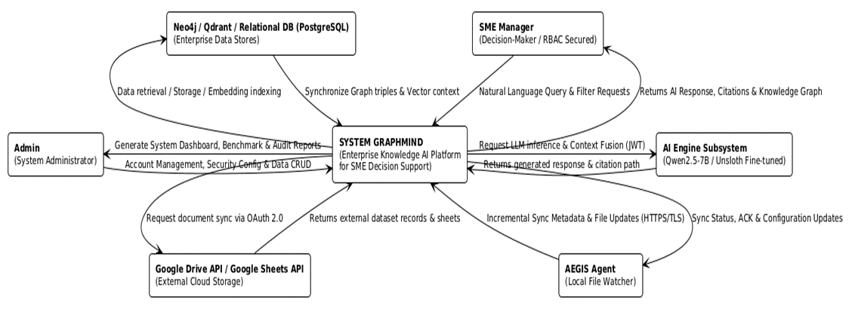
Figure 3.1 — GraphMind System Context Diagram

3.2 Product Functions
Key functions include:
- Log in to JWT/OAuth 2.0 and decentralize RBAC.
- Manage accounts, departments, and data scope (Department/Data Scope).
- Synchronize local data via AEGIS Local Agent (incremental synchronization).
- Manage and edit the Knowledge Base (Document Explorer, Knowledge Editor, SOP Editor).
- AI Copilot single-step, 2-step and cross-source (single-hop/2-hop/cross-source) Q&A.
- Knowledge Graph Viewer visualization.
- Cite the source for every answer (Source & Citation Viewer).
- Decision support dashboard (Home Dashboard, Executive Dashboard).
- Warning of expiring contract risks and fluctuations in customer behavior.
- Enterprise Multi-facet Search.
- Fine-tuning model, benchmark and measurement of 5 evaluation indicators.

3.3 User Characteristics
User Type | Description | Skills
Admin (System & Knowledge Administrator) | System administration, Agent installation, RBAC decentralization, AI-extracted knowledge browsing. | Good IT skills
Executive | SME leaders, access to all data, view business metrics, risk alerts, cross-source strategy Q&A. | Management Operations
Department Manager | Manage departments within departments, prepare internal SOPs/regulations, use AI Copilot departments. | Department Operations
Standard User | Sales, Accounting, HR, Legal, IT: policy/product/customer Q&A, view quotes and knowledge maps in Data Scope. | General users

3.4 Constraints
- Duration: 13 weeks (01/09/2026 – 01/12/2026), divided into 4 Sprints.
- Budget: 0 VND — DTU student research project, using free/open source tools only.
- Hardware: Kaggle Notebook with NVIDIA T4 GPU, approx. 30 hours/week; ceiling fine-tuning speed ~51 s/step.
- Data: using real AdventureWorks and CUAD data; Controlled Synthetic Linking is stored in an independent lookup table.
- Browser: supports Chrome, Edge, Firefox on desktop.

3.5 Assumptions and Dependencies
- AdventureWorks and CUAD data are allowed to be used for academic/research purposes.
- Kaggle offers enough free GPU quota to complete fine-tuning models.
- The Review Panel and Project Mentor accepted the Controlled Synthetic Linking methodology.
- The system relies on three databases Neo4j, Qdrant and PostgreSQL to operate stably.
- Stable Internet connection between AEGIS Agent, server and client.

4. Specific Requirements

4.1 Functional Requirements
Code | Functional Requirements Description | Priority
FR1 | The system allows users to log in with email and password, authenticate with JWT. | High
FR2 | The system allows account registration, forgotten password and OTP authentication. | High
FR3 | The system decentralizes access to functions and data according to RBAC, Department Scope, and Data Scope. | High
FR4 | The system supports OAuth 2.0 for Google Drive/Sheets authentication and authorization flows. | Medium
FR5 | Admin manages accounts, departments, assigns 1 of 4 roles and configures data scope. | High
FR6 | The system records all queries and administrative operations in the Audit Log. | High
FR7 | HTTPS/TLS encryption system when synchronizing Agent – Cloud; sensitive original data is kept locally. | High
FR8 | The system saves accounts, RBAC policies, metadata, and audit logs on PostgreSQL. | High
FR9 | The system provides the Admin Analytics Dashboard with user statistics, RBAC, and AI activity. | Medium
FR10 | Admin monitors Neo4j/Qdrant data status and schema conflict alerts. [Optional] | Low
FR11 | Admin performs CRUD on Neo4j and Qdrant from the Admin Panel. [Optional] | Low
FR12 | The system provides an LLMOps & Cost Dashboard that tracks fine-tuning and inference latency. [Optional] | Low
FR13 | AEGIS Local Agent monitors local directories and incremental synchronization to the Backend Cloud. | High
FR14 | The AEGIS Local Agent Panel displays the Online/Offline status, directory configuration, and sync mode. | Medium
FR15 | The system provides a File Watcher API that tracks file creation/edit/deletion events. | High
FR16 | The system provides a Document Ingestion API for loading PDF contracts and order data files. | High
FR17 | The system performs ETL, standardization and chunking of AdventureWorks and CUAD data. | High
FR18 | The system assigns each Customer 1–3 CUAD contracts using Controlled Synthetic Linking. | High
FR19 | The system connects and syncs data from Google Drive/Sheets API. [Optional] | Low
FR20 | Entity extraction, relational, and deduplication system (NER/RE/Entity Resolution). | High
FR21 | The system builds the Knowledge Graph on Neo4j according to schema mapping and incremental updates. | High
FR22 | The system generates embedding and indexing into Qdrant, synchronizing as the source data changes. | High
FR23 | The system provides Document & Data Explorer with file preview under RBAC permissions. | Medium
FR24 | Admins edit AI-extracted entities/relationships via Knowledge Editor (human-in-the-loop). | High
FR25 | Editing in the Knowledge Editor is synchronized to Neo4j and Qdrant for AI to use new knowledge. | Medium
FR26 | Department Manager drafts and publishes SOPs/regulations for his department. | Medium
FR27 | Chat UI supports multi-turn conversations on CRM/ERP and contract data, with source citations. | High
FR28 | The system accurately answers single-hop questions. | High
FR29 | The system answers 2-step questions (2-hop) by browsing graphs on Neo4j. | High
FR30 | The system answers cross-source questions and quotes both CRM data and contract terms. | High
FR31 | Hybrid Query Engine analyzes questions, generates cyphers, finds parallel vectors, and merges contexts. | High
FR32 | Source & Citation Viewer displays citations to specific tables/columns/values or contract terms. | High
FR33 | Knowledge Graph Viewer displays entities and relationships within the allowed data range. | High
FR34 | The system provides a Web Dashboard (React/Next.js) for backend communication via REST API. | High
FR35 | The fine-tuned Qwen2.5-7B-Instruct is self-hosted and called by FastAPI to generate answers. | High
FR36 | LoRA/PEFT fine-tuning system on Kaggle and periodic checkpoints are saved to the Hugging Face Hub. | High
FR37 | The system uses a dataset of 2,000–3,000 Q&A pairs divided 80/10/10 for coaching. | High
FR38 | The system displays the reliability index with AI answers. [Optional] | Low
FR39 | The system saves chat history and pins important Q&A sessions into shared documents. [Optional] | Low
FR40 | After logging in, the system displays the Home & Dashboard page according to the user's permissions. | High
FR41 | The Executive Decision Dashboard displays revenue, high-value customers, and contract type distribution. | Medium
FR42 | The Smart Risk & Alert Center warns that contracts expire in 15–30 days and VIP customers reduce their orders. | Medium
FR43 | Standard User only receives alerts within the scope of the data granted. [Optional] | Low
FR44 | Executive Briefing Generator summarizes the business situation and exports PDF/Word files. [Optional] | Low
FR45 | Unified search by keyword on Customers, Products, Contracts, and documents. | High
FR46 | Multifaceted filters by department, creation date, transaction value, and document validity status. | High
FR47 | The system is evaluated on a benchmark of 100–200 questions at 3 levels of complexity. | Medium
FR48 | The system implements 3 baselines: Vector RAG, Pure GraphRAG, and Hybrid GraphRAG. | Medium
FR49 | The system measures Answer Correctness by ground truth, LLM-as-Judge and manual testing. | Medium
FR50 | Retrieval/Citation Precision, Hallucination Rate and AI Response Time measurement system. | Medium
FR51 | The system measures the Fine-tuning Effectiveness between the original model and the fine-tuned model. | Medium
FR52 | The team prepared a report comparing three baselines on 5 evaluation indicators. | Medium

Note: 52 functional requirements, of which 45 are required (Core) and 7 are optional (Optional/Stretch) are marked [Optional].

4.2 Non-functional Requirements
Type | Requirements
Performance | AI Response Time is automatically measured for every query; fine-tuning operates in a ceiling of ~51 s/step on the T4 GPU.
Security | JWT authentication, OAuth 2.0 authorization, multi-level RBAC decentralization, HTTPS/TLS encryption when syncing AEGIS Agent, sensitive data stored locally, full Audit Log logging.
Reliability | Periodically save checkpoints for LoRA/PEFT on Kaggle/Hugging Face Hub so that no progress is lost; data loading errors are logged and allowed to run again.
Availability | The system works stably on the Hybrid Deployment architecture (Agent + Cloud Backend); Agent disconnection does not interrupt queries on synchronized data.
Usability | The web interface is easy to use for non-professional employees; all AI answers are verifiable through source citations and knowledge graphs.
Scalability | Standardized Schema Mapping design makes it easy to expand the enterprise entity; three independently scalable databases.

4.3 External Interface Requirements
- UI: Web Dashboard responsive (React/Next.js) including Chat UI, Source & Citation Viewer, Knowledge Graph Viewer, Executive Dashboard, Admin Panel.
- DB: Neo4j (Graph), Qdrant (Vector), PostgreSQL (Relational).
- API: REST API (FastAPI) JSON data return; Neo4j Cypher API; Qdrant Vector API; self-hosted LLM inference endpoint.
- Hardware/Network: HTTPS/TLS connection between AEGIS Agent and Backend Cloud; GPU server for inference.
- Security: SSL/TLS, JWT authentication, OAuth 2.0 authorization.

5. System Models

5.1 Business Function Diagram (BFD)
The BFD diagram decomposes the system into 6 level 1 modules and level 2 functions as shown below.
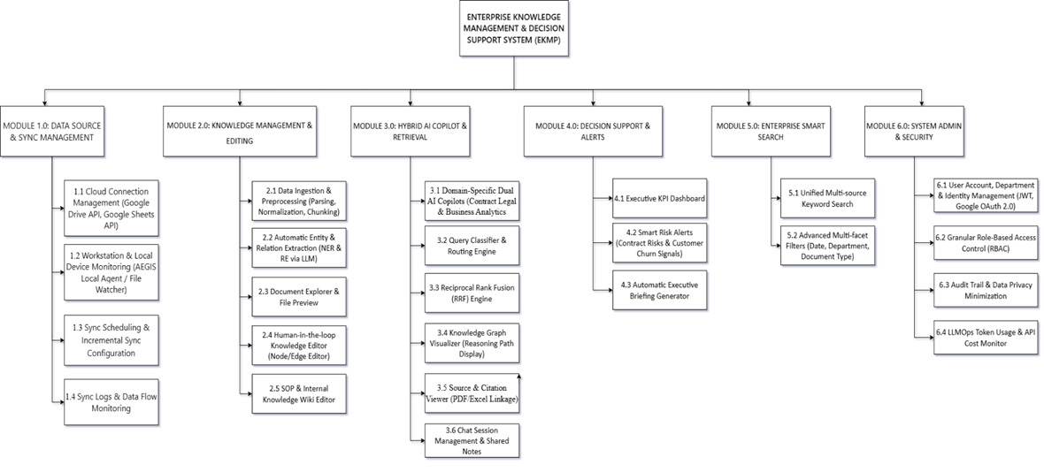
Figure 5.1 — GraphMind System Business Function Diagram (BFD)

5.2 List of Use Cases
Use case ID | Use case name | Functional Req.
UC.01 | System Login | FR1, FR2, FR4
UC.02 | Manage accounts, departments & user identities | FR5, FR8
UC.03 | Granular Access Permissions (RBAC) | FR3, FR5
UC.04 | View audit logs & data protection | FR6, FR7
UC.05 | Token Monitoring & LLMOps Costs | FR12, FR9
UC.06 | Manage cloud data source connections | FR19, FR4
UC.07 | Workstation Monitoring & AEGIS Local Agent | FR14, FR13
UC.08 | Sync calendar configuration & incremental sync | FR13, FR15
UC.09 | Sync Log & Data Flow Tracking | FR14, FR6
UC.10 | Data Loading & Preprocessing | FR16, FR17, FR18
UC.11 | Automated entity & relationship extraction | FR20, FR21, FR22
UC.12 | Browse documents & preview files | FR23
UC.13 | Human-involved knowledge editing | FR24, FR25
UC.14 | Drafting SOPs & internal knowledge wikis | FR26
UC.15 | Q&A with AI Copilot Hybrid (Hybrid GraphRAG) | FR27, FR28, FR29, FR30, FR31, FR35
UC.16 | View knowledge graphs & inference lines | FR33, FR21
UC.17 | See source citations | FR32
UC.18 | Manage chat sessions & shared notes | FR39
UC.19 | View the Executive KPI table | FR40, FR41
UC.20 | Intelligent Risk Alert Tracking | FR42, FR43
UC.21 | Generate automated executive summary reports | FR44
UC.22 | Multi-faceted merged search & filtering | FR45, FR46

5.3 Use Case Diagram Overview
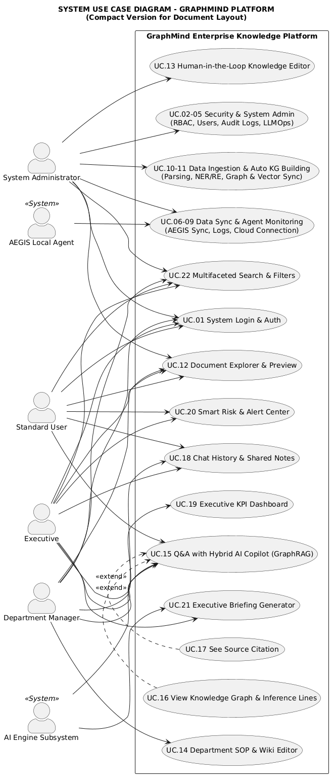

5.4 Use Case Specification:
The UC specification for each UC follows the taught form.

UC.01 — System Login
Use Case ID | UC.01
Use Case Name | System Login
Created by | Tran Thi Ngoc Anh | Last updated by | Tran Thi Ngoc Anh
Date Created | Sep 19, 2026 | Date last updated | Sep 2026
Actors | User (4 roles), Authentication System (JWT/OAuth 2.0)
Brief Description | The user logs in with a valid email and password to enter the system in accordance with the permissions granted.
Goal | Allow users to access the system within the scope of their permissions.
Trigger | The user opens the login page and sends a login request.
Pre-conditions | - The account has been created by the Admin and is active.  - System and PostgreSQL are active.
Post-conditions | - Success: create a JWT session, download RBAC permissions, go to the Home & Dashboard page.  - Failure: did not create a session, logged login error.
Main Flow | 1. The user opens the login page.  2. The user enters the email and password.  3. Input data format inspection system.  4. The system compares information with the database.  5. JWT level system and RBAC right loading.  6. Go to the Home & Dashboard page.
Alternative Flow | A1: Log in using OAuth 2.0 → the provider authorization system and then proceed to step 5.  A2: Forgot the password → the system sent the OTP, the user resets the password, return to step 2.
Exception Flow | E1: Wrong email/password → reported an error, did not create a session.  E2: Wrong or expired OTP → report an error, allow re-request.  E3: Locked account → report an error, please contact Admin.
Priority | High
Business Rule | BR-02, BR-05

UC.02 — Manage accounts, departments & user identities
Use Case ID | UC.02
Use Case Name | Manage accounts, departments & user identities
Created by | Tran Thi Ngoc Anh | Last updated by | Tran Thi Ngoc Anh
Date Created | Sep 19, 2026 | Date last updated | Sep 2026
Actors | System & Knowledge Administrator, PostgreSQL
Brief Description | Admins create, edit, and delete employee accounts and organize users by department.
Goal | Make sure each employee has an account in the right department and in the right role.
Trigger | Admin opens the User Management screen in the Admin Panel.
Pre-conditions | - Admin is logged in as Admin (UC.01).
Post-conditions | - Success: the account is saved to PostgreSQL and the Audit Log is recorded.  - Failure: no data change, error displayed.
Main Flow | 1. Admin opens the User Management screen.  2. The system displays the list of accounts by department.  3. Admin select Add New or Edit Account.  4. Admin enter the information and select the department.  5. Duplicate testing and data saving system.  6. Audit Log recording system and updating the list.
Alternative Flow | A1: Admin disables the account instead of deleting it.  A2: Admin creates a new department before assigning a user.
Exception Flow | E1: The email already exists → duplicate error message.  E2: Missing field requires → report an error and keep the input data intact.
Priority | High
Business Rule | BR-02, BR-03

UC.03—Granular Access Authorization (RBAC)
Use Case ID | UC.03
Use Case Name | Granular Access Permissions (RBAC)
Created by | Tran Thi Ngoc Anh | Last updated by | Tran Thi Ngoc Anh
Date Created | Sep 19, 2026 | Date last updated | Sep 2026
Actors | System & Knowledge Administrator
Brief Description | Admin assigns system roles and configures Department Scope, Data Scope to each user.
Goal | Make sure that each role can query only the knowledge that is allowed.
Trigger | Admin opens the RBAC Decentralization screen.
Pre-conditions | - The admin is logged in.  - The account that needs to be decentralized already exists.
Post-conditions | - Success: the RBAC policy is saved and applied immediately to the next session.  - Any permission changes are logged in the Audit Log.
Main Flow | 1. Admin selects the user to decentralize.  2. Admin assigns 1 of 4 system roles.  3. Admin configures Department Scope and Data Scope.  4. The system checks the validity of the policy.  5. The system saves policies and records Audit Log.
Alternative Flow | A1: Admins assign permissions by group/department instead of each person.  A2: The admin copies the permission configuration from another user.
Exception Flow | E1: Conflicting policies → the system refuses to save and warn.  E2: Assign permissions that exceed authority → deny system.
Priority | High
Business Rule | BR-02, BR-04, BR-05

UC.04 — Audit Log View & Data Protection
Use Case ID | UC.04
Use Case Name | View audit logs & data protection
Created by | Tran Viet Anh Vu | Last updated by | Tran Viet Anh Vu
Date Created | Sep 19, 2026 | Date last updated | Sep 2026
Actors | System & Knowledge Administrator
Brief Description | Admins view the system's query history, administrative operations, and security configurations.
Goal | Ensure that all behaviors on the system are traceable.
Trigger | The admin opens the Audit Trail screen.
Pre-conditions | - The admin is logged in.  - The system has logged to PostgreSQL.
Post-conditions | - Logs are displayed by filter; can be exported to a report file.
Main Flow | 1. Admin opens the Audit Trail screen.  2. Admin selects filters by user, time or type of action.  3. Log query system from PostgreSQL.  4. The system displays the list of records.  5. Admin view details or export reports.
Alternative Flow | A1: Admins view the security event logs (login errors, TLS errors) separately.  A2: Admin configures the policy to minimize sensitive data.
Exception Flow | E1: There is no matching record → display a blank message.  E2: A database query error → a service error.
Priority | High
Business Rule | BR-02, BR-03

UC.05 — LLMOps Token & Cost Monitoring
Use Case ID | UC.05
Use Case Name | Token Monitoring & LLMOps Costs
Created by | Huynh Ngoc Minh | Last updated by | Huynh Ngoc Minh
Date Created | Sep 19, 2026 | Date last updated | Sep 2026
Actors | System & Knowledge Administrator
Brief Description | The admin keeps track of the number of tokens used, GPU training time, and inference latency of the model. [Optional]
Goal | Control the computational cost and performance of the AI model.
Trigger | Admin opens LLMOps & Cost Dashboard.
Pre-conditions | - The admin is logged in.  - The system has recorded the model operation data.
Post-conditions | - Token, GPU, and latency statistics table is displayed.
Main Flow | 1. Open the LLMOps & Cost Dashboard.  2. Admin select the statistical time period.  3. The system aggregates the number of tokens, GPU sessions, and inference latency.  4. Graph and metric table display system.
Alternative Flow | A1: The admin exports the data to a file for the research report.
Exception Flow | E1: Missing data in the → period displays an insufficient data message.
Priority | Low
Business Rule | BR-03

UC.06 — Cloud Data Source Connection Management
Use Case ID | UC.06
Use Case Name | Manage cloud data source connections
Created by | Tran Viet Anh Vu | Last updated by | Tran Viet Anh Vu
Date Created | Sep 19, 2026 | Date last updated | Sep 2026
Actors | System & Knowledge Administrator, Google Drive/Sheets API
Brief Description | Admin configures and authenticates Google Drive/Sheets accounts via OAuth 2.0 to supplement data sources. [Optional]
Goal | Extend the system's data source beyond local data.
Trigger | The admin opens the Cloud Connection Management screen.
Pre-conditions | - The admin is logged in.  - Have a valid Google account.
Post-conditions | - Success: the connection is saved and the source data is ready to sync.
Main Flow | 1. Admin opens the connection management screen.  2. Admin choose to add a Google Drive or Google Sheets source.  3. The system redirects to the OAuth 2.0 authorization flow.  4. The user grants permissions to the system.  5. The system saves access tokens and connection status.
Alternative Flow | A1: Admin revokes the configured connection.  A2: Admin selects the range of folders/spreadsheets to be synced.
Exception Flow | E1: The user refuses to grant permission → the connection is not created.  E2: The token expires → the system requires revalidation.
Priority | Low
Business Rule | BR-02, BR-03

UC.07 — Workstation Monitoring & AEGIS Local Agent
Use Case ID | UC.07
Use Case Name | Workstation Monitoring & AEGIS Local Agent
Created by | Tran Viet Anh Vu | Last updated by | Tran Viet Anh Vu
Date Created | Sep 19, 2026 | Date last updated | Sep 2026
Actors | System & Knowledge Administrator, AEGIS Local Agent
Brief Description | The admin can view the list of workstations where the Agent is installed, the Online/Offline status, and the directory being monitored.
Goal | Control the operational status of local sync agents.
Trigger | Admin opens the AEGIS Local Agent Panel.
Pre-conditions | - The admin is logged in.  - At least one Agent has been installed and registered.
Post-conditions | - Workstation list and status are displayed correctly.
Main Flow | 1. Open the AEGIS Local Agent Panel.  2. The system queries the status of registered agents.  3. The system displays the workstation name, status and monitoring folder.  4. Admin selects an agent to view the details.
Alternative Flow | A1: Admin registers a new workstation.  A2: The admin suspends or unregisters an agent.
Exception Flow | E1: The agent loses connection → displays the Offline status and the last active time.
Priority | High
Business Rule | BR-03

UC.08 — Sync Calendar Configuration & Incremental Sync
Use Case ID | UC.08
Use Case Name | Sync calendar configuration & incremental sync
Created by | Tran Viet Anh Vu | Last updated by | Tran Viet Anh Vu
Date Created | Sep 19, 2026 | Date last updated | Sep 2026
Actors | System & Knowledge Administrator, AEGIS Local Agent, Backend Cloud
Brief Description | The agent detects the file change in the monitoring directory and sends the change to the Backend Cloud via HTTPS/TLS.
Goal | Keep your knowledge base up to date without having to manually load files.
Trigger | Have the file change, go to the sync calendar, or click Admin manually sync.
Pre-conditions | - The agent is online and has configured the monitoring folder.  - Backend Cloud and active databases.
Post-conditions | - Success: change data is loaded and the knowledge base is incrementally updated.  - Failure: mark the sync error, keep the same state.
Main Flow | 1. Admin selects sync mode (real-time or recurring).  2. The agent detects the file creation/edit/delete event.  3. The agent sends the change to the Backend via HTTPS/TLS.  4. Backend validity check and input into the data feeding pipeline.  5. Neo4j and Qdrant incremental update system.  6. Synchronous result recording system.
Alternative Flow | A1: Sync according to the schedule → skip step 1.  A2: The first sync → all files in the folder are considered new data.  A3: The file deletion event → delete the node/relationship and embedding respectively.
Exception Flow | E1: Lost connection → postpone sync, re-run by itself when network is available.  E2: TLS authentication error → the backend rejects packets, logging security.  E3: File error → skip file and log review.
Priority | High
Business Rule | BR-02, BR-03

UC.09 — Sync Log & Data Flow Monitoring
Use Case ID | UC.09
Use Case Name | Sync Log & Data Flow Tracking
Created by | Huynh Ngoc Minh | Last updated by | Huynh Ngoc Minh
Date Created | Sep 19, 2026 | Date last updated | Sep 2026
Actors | System & Knowledge Administrator
Brief Description | The admin views the sync history including the number of files loaded, the number of extracted records, and error messages.
Goal | Help admins detect problems in the data stream early.
Trigger | The admin opens the Sync Logs & Data Flow Monitoring screen.
Pre-conditions | - The admin is logged in.  - Have had at least one sync.
Post-conditions | - Sync logs are displayed by workstation and over time.
Main Flow | 1. Admin opens the sync log screen.  2. Admin select the workstation and time period.  3. Log query system from PostgreSQL.  4. The system displays the file number, record number and error list.
Alternative Flow | A1: The admin re-runs a sync error from the log screen.
Exception Flow | E1: There is no record → show a blank message.
Priority | Medium
Business Rule | BR-03

UC.10 — Data Loading & Preprocessing
Use Case ID | UC.10
Use Case Name | Data Loading & Preprocessing
Created by | Huynh Ngoc Minh | Last updated by | Huynh Ngoc Minh
Date Created | Sep 19, 2026 | Date last updated | Sep 2026
Actors | Research Team / System, AEGIS Local Agent
Brief Description | The system feeds AdventureWorks and CUAD data, performing parsing, normalization, and text fragmentation.
Goal | Standardize raw data to be ready for knowledge extraction.
Trigger | There is new data that is loaded via the Document Ingestion API or via Agent sync.
Pre-conditions | - The data source has been configured.  - The pipeline feeds active data.
Post-conditions | - Standardized and chunk data, ready for NER/RE.  - Logged formatting errors.
Main Flow | 1. The system receives a new data file or record.  2. Text content parsing and parsing system.  3. Data format standardization system.  4. The system splits the text into chunks accordingly.  5. Customer-Contract linkage assignment system according to an independent lookup table.  6. The system saves the results and logs.
Alternative Flow | A1: Structured data (AdventureWorks) → skip the text extraction step.  A2: The PDF Contract (CUAD) → add a text extraction step.
Exception Flow | E1: Corrupted or unreadable files → skip and log.  E2: Invalid data → log errors for review.
Priority | High
Business Rule | BR-01

UC.11 — Automatic Entity & Relational Extraction
Use Case ID | UC.11
Use Case Name | Automated entity & relationship extraction
Created by | Huynh Ngoc Minh | Last updated by | Huynh Ngoc Minh
Date Created | Sep 19, 2026 | Date last updated | Sep 2026
Actors | System (NER/RE by LLM), Neo4j, Qdrant
Brief Description | The system recognizes entities, relationships, deduplicates, and then builds the Knowledge Graph and indexes the embedding.
Goal | Turn normalized data into queryable structured knowledge.
Trigger | The data has passed the pre-processing step (UC.10).
Pre-conditions | - Normalized and chunk data.  - Schema mapping has been defined.
Post-conditions | - Nodes and relationships are written to Neo4j; embedding is written to Qdrant.
Main Flow | 1. The system runs NER to identify entities according to schema mapping.  2. The system runs RE for relational recognition between entities.  3. Entity Resolution system.  4. Node and relationship recording system to Neo4j.  5. The system generates embeddings and indexes them into Qdrant.
Alternative Flow | A1: Data that already exists → incremental update instead of creating new ones.  A2: The data is deleted → node/relationship deletion and embedding respectively.
Exception Flow | E1: Low Reliability Extraction Results → Waiting for Admin Review (UC.13).  E2: DB write error → data batch rollback and logging.
Priority | High
Business Rule | BR-01

UC.12 — Document Browsing & File Preview
Use Case ID | UC.12
Use Case Name | Browse documents & preview files
Created by | Ha Hoang Anh | Last updated by | Ha Hoang Anh
Date Created | Sep 19, 2026 | Date last updated | Sep 2026
Actors | Admin, Department Manager, Standard User
Brief Description | The user browses the list of loaded documents and previews the file contents within the scope of the granted permissions.
Goal | Help users check what data has been put into the system.
Trigger | The user opens Document & Data Explorer.
Pre-conditions | - The user is logged in.  - Documents have been loaded into the system.
Post-conditions | - A list of documents within the permission scope is displayed.
Main Flow | 1. The user opens Document & Data Explorer.  2. The system reads the user's RBAC permissions.  3. The system displays a list of documents that are allowed to be viewed.  4. The user selects a document.  5. The system opens a file content preview window.
Alternative Flow | A1: Users filter documents by type, department, or loading date.  A2: The user opens the document from a source citation (UC.17).
Exception Flow | E1: Documents outside the scope of → permissions are not displayed in the list.  E2: Failed to preview the file format → allowed for download.
Priority | Medium
Business Rule | BR-02

UC.13 — Human-Involved Knowledge Editing
Use Case ID | UC.13
Use Case Name | Human-involved knowledge editing
Created by | Ha Hoang Anh | Last updated by | Ha Hoang Anh
Date Created | Sep 19, 2026 | Date last updated | Sep 2026
Actors | System & Knowledge Administrator, Neo4j, Qdrant
Brief Description | Admins view AI-extracted entities and relationships, fix wrong nodes/edges, and re-sync them to AI Copilot.
Goal | Improve the accuracy of your knowledge base without having to rerun the entire pipeline.
Trigger | The admin opens the Knowledge Editor or receives a low-reliability extraction warning.
Pre-conditions | - The admin is logged in.  - The Knowledge Graph has been built.
Post-conditions | - Success: change logged to Neo4j and Qdrant, Audit Log.  - AI Copilot uses corrected knowledge for subsequent questions.
Main Flow | 1. Open the Knowledge Editor.  2. AI-extracted entity and relationship display system.  3. Admin select the node or edge to be edited.  4. Admin edits, adds, or deletes nodes/relationships.  5. Record system changes to Neo4j.  6. The system updates the corresponding embedding on Qdrant and records the Audit Log.
Alternative Flow | A1: Admin browse the extracts in bulk pending confirmation.  A2: The admin reattaches the source document to an entity.
Exception Flow | E1: Changes that break the schema constraints → the rejection and warning system.  E2: Embedding sync error → mark the need to run again.
Priority | High
Business Rule | BR-03

UC.14 — SOP Drafting & Internal Knowledge Wiki
Use Case ID | UC.14
Use Case Name | Drafting SOPs & internal knowledge wikis
Created by | Phan Anh Bao | Last updated by | Phan Anh Bao
Date Created | Sep 19, 2026 | Date last updated | Sep 2026
Actors | Department Manager
Brief Description | The head of the department drafts and publishes internal processes and regulations directly on the web.
Goal | Help employees in the department always have up-to-date internal processes.
Trigger | Department Manager accesses the SOP Editor.
Pre-conditions | - The user is logged in with the Department Manager role.
Post-conditions | - SOP documents are saved and displayed in the department's internal knowledge base.
Main Flow | 1. The department head opens the SOP editor.  2. Department Manager creates new or opens existing documents.  3. The head of the department shall prepare the contents of the process/regulations.  4. The head of the department shall save the draft.  5. The head of the department presses publishing.  6. The system checks rights and puts documents into the internal knowledge repository.
Alternative Flow | A1: The Head of Department will save the draft and publish it at the next login.  A2: The head of the department removes an outdated document.
Exception Flow | E1: Published to other departments → rejection system under BR-04.  E2: Disconnection is lost when composing → the system holds drafts automatically.
Priority | Medium
Business Rule | BR-04

UC.15 — Q&A with Hybrid AI Copilot (Hybrid GraphRAG)
Use Case ID | UC.15
Use Case Name | Q&A with AI Copilot Hybrid (Hybrid GraphRAG)
Created by | Huynh Ngoc Minh | Last updated by | Huynh Ngoc Minh
Date Created | Sep 19, 2026 | Date last updated | Sep 2026
Actors | Executive, Department Manager, Standard User, AI Engine (Qwen2.5-7B fine-tuned), Neo4j, Qdrant
Brief Description | Users ask natural language questions; the system classifies questions, retrieves them on Neo4j and Qdrant, merges the results, and then generates answers with citations.
Goal | Get synthetic, verifiable answers without having to manually look up each system.
Trigger | The user submits a question on the Chat UI.
Pre-conditions | - The user is logged in and has a valid Data Scope.  - Knowledge Graph and embedding are ready.  - Active model inference services.
Post-conditions | - Success: display answers with quotes, save chat history, measure AI Response Time and record Audit Log.  - Failure: report an error, do not fabricate an answer.
Main Flow | 1. The user enters the question and submits it.  2. The system attaches RBAC and Data Scope permissions to the request.  3. Query Classifier classifies and routes questions.  4. Cypher generation system and graph browsing on Neo4j.  5. In parallel, the vector search system on Qdrant.  6. The system consolidates and ranks the results by RRF.  7. The system feeds the context into a fine-tuned model to generate answers.  8. Source citation mounting system and result display.
Alternative Flow | A1: Single-step questions → retrieved on only one data source.  A2: 2-hop Question → browse two consecutive relationships on Neo4j.  A3: Cross-Source Questions → combine the Customer–Order–Contract link with the term search.  A4: The follow-up question → reuse the context of the previous conversation.
Exception Flow | E1: Couldn't find the right context → the message has no supporting data.  E2: Invalid Cypher statement → switch to vector results.  E3: The inference service or the database fails to → errors and logs.
Priority | High
Business Rule | BR-01, BR-02, BR-05

UC.16 — View Knowledge Graphs & Inference Lines
Use Case ID | UC.16
Use Case Name | View knowledge graphs & inference lines
Created by | Ha Hoang Anh | Last updated by | Ha Hoang Anh
Date Created | Sep 19, 2026 | Date last updated | Sep 2026
Actors | Executive, Department Manager, Standard User, Neo4j
Brief Description | Users view the entity-relational diagram, or view the graph as evidence for an AI answer.
Goal | Visualize and verify business relationships before making decisions.
Trigger | The user opens the Knowledge Graph Visualizer or clicks "view inference line" on an answer.
Pre-conditions | - The user is logged in.  - The Knowledge Graph has been built on Neo4j.
Post-conditions | - Nodes and relationships within the allowed range are displayed.
Main Flow | 1. The user opens the Knowledge Graph Visualizer.  2. RBAC and Data Scope permission reading system.  3. Neo4j query system according to the permitted range.  4. Node and relationship display system.  5. The user expands the node to view the path to the Customer → Order → Product or Customer → Contract.  6. The user selects the node to view the detailed properties.
Alternative Flow | A1: Enter the Chat UI → only display and highlight the graph as evidence.  A2: The user filters the graph by entity type or department.
Exception Flow | E1: There are no entities within range → display empty messages.  E2: Neo4j does not respond → service error report.  E3: The graph is too large → limit the number of nodes and require narrowing of the filter.
Priority | High
Business Rule | BR-01, BR-02, BR-05

UC.17 — See source citation
Use Case ID | UC.17
Use Case Name | See source citations
Created by | Phan Anh Bao | Last updated by | Phan Anh Bao
Date Created | Sep 19, 2026 | Date last updated | Sep 2026
Actors | Executive, Department Manager, Standard User
Brief Description | The user opens the quote of the answer to see the original data record or the corresponding contract snippet.
Goal | Verify the reliability of answers, avoid the risk of fabricated information.
Trigger | The user clicks on a quote in the AI's answer.
Pre-conditions | - Answers with citations (UC.15).  - The source document/record is in the user's Data Scope.
Post-conditions | - The original contract snippet or data record is displayed.
Main Flow | 1. The user clicks on the quote.  2. The system defines the table/column/value or ContractID and ClauseType respectively.  3. User access checking system.  4. Open Source & Citation Viewer.  5. The system highlights the quoted snippet of content.
Alternative Flow | A1: The user opens the full original document in Document Explorer (UC.12).  A2: The user switches to the evidence graph (UC.16).
Exception Flow | E1: The citation is outside the Data Scope → the system denies and permissions restriction messages.  E2: The source document has been deleted → the source message is no longer available.
Priority | High
Business Rule | BR-02

UC.18 — Chat Session Management & Shared Notes
Use Case ID | UC.18
Use Case Name | Manage chat sessions & shared notes
Created by | Phan Anh Bao | Last updated by | Phan Anh Bao
Date Created | Sep 19, 2026 | Date last updated | Sep 2026
Actors | Executive, Department Manager, Standard User
Brief Description | Users review conversation history and pin important Q&A sessions into shared documents. [Optional]
Goal | Keep and share valuable answers for the whole team.
Trigger | The user opens the chat session list.
Pre-conditions | - The user is logged in and has had at least one chat session.
Post-conditions | - The session is reopened or pinned to a shared document.
Main Flow | 1. The user opens the chat session list.  2. The system displays sessions by time.  3. The user chooses to reopen a session.  4. Users pin sessions and add notes.  5. The system saves the session as a shared document.
Alternative Flow | A1: The user changes the name or deletes a chat session.  A2: The user shares the session with fellow department members.
Exception Flow | E1: The person who opened the session shared insufficient permissions with the data in the session→ the system hides the override content.
Priority | Low
Business Rule | BR-02

UC.19 — View Executive KPIs
Use Case ID | UC.19
Use Case Name | View the Executive KPI table
Created by | Phan Anh Bao | Last updated by | Phan Anh Bao
Date Created | Sep 19, 2026 | Date last updated | Sep 2026
Actors | Executive
Brief Description | Leaders view a graph that summarizes revenue, high-value customers, contract type distribution, and terms compliance rates.
Goal | Track core business metrics without manual aggregation.
Trigger | Leaders open the Executive KPI Dashboard.
Pre-conditions | - The user is logged in as an Executive.  - The data has been synced to the knowledge base.
Post-conditions | - KPI charts are displayed with the latest data.
Main Flow | 1. Open Executive KPI Dashboard.  2. The system of querying aggregated data from the knowledge base.  3. The system displays revenue charts over time and high-value customer groups.  4. The system displays the distribution of contract types and the rate of compliance with the terms.  5. Leaders select an indicator to view in detail.
Alternative Flow | A1: Leadership filters by time period or department.  A2: The leader moves from a chart to asking AI Copilot about that metric (UC.15).
Exception Flow | E1: Data has not been synced → displays an unupdated data warning.  E2: A query error → a service error.
Priority | Medium
Business Rule | BR-05

UC.20 — Intelligent Risk Alert Tracking
Use Case ID | UC.20
Use Case Name | Intelligent Risk Alert Tracking
Created by | Tran Thi Ngoc Anh | Last updated by | Tran Thi Ngoc Anh
Date Created | Sep 19, 2026 | Date last updated | Sep 2026
Actors | Executive, Standard User (optional)
Brief Description | The system warns that the contract is about to expire in 15–30 days, and VIP customers show signs of decreasing the frequency of orders.
Goal | Early detection of legal and business risks.
Trigger | Users open the Smart Risk & Alert Center or the system to generate scheduled alerts.
Pre-conditions | - The user is logged in.  - Contract and order data have been synchronized.
Post-conditions | - The list of alerts in the scope of permissions is displayed and the Audit Log is logged.
Main Flow | 1. The system reviews the contract expiration date and order frequency of customers.  2. Corresponding Warning Generating System.  3. The user opens the Smart Risk & Alert Center.  4. Alarm filtering system according to the user's Data Scope.  5. The system displays a list of warnings with priority.  6. The user selects an alert to view the relevant contract or customer.
Alternative Flow | A1: The markup user has processed an alert.  A2: The user turns to ask AI Copilot about that risk (UC.15).
Exception Flow | E1: No alarm → display empty message.  E2: Alerts belonging to other departments → not visible to Standard Users.
Priority | Medium
Business Rule | BR-02, BR-05

UC.21 — Automatic Executive Summary Report Generation
Use Case ID | UC.21
Use Case Name | Generate automated executive summary reports
Created by | Tran Thi Ngoc Anh | Last updated by | Tran Thi Ngoc Anh
Date Created | Sep 19, 2026 | Date last updated | Sep 2026
Actors | Executive, AI Engine
Brief Description | Leaders press a button for AI to summarize the business situation, debts, and contracts into a report file. [Optional]
Goal | Shorten the time to synthesize periodic reports.
Trigger | Leaders click the button to create an Executive Briefing.
Pre-conditions | - The user is logged in as an Executive.  - Data in the reporting period has been synchronized.
Post-conditions | - PDF or Word report files are generated and available for download.
Main Flow | 1. Leaders choose the reporting period (week or month).  2. Leaders click the button to create a report.  3. The system of aggregating business data, debts and contracts in the period.  4. The system feeds data into the model to generate a summary.  5. The system exports the report to PDF/Word file.
Alternative Flow | A1: The leader edits the summary before exporting the file.
Exception Flow | E1: Missing data in the → incomplete reporting warning system.  E2: A file generation error → report an error and allow a retry.
Priority | Low
Business Rule | BR-05

UC.22 — Multifaceted Unified Search & Filtering
Use Case ID | UC.22
Use Case Name | Multi-faceted merged search & filtering
Created by | Ha Hoang Anh | Last updated by | Ha Hoang Anh
Date Created | Sep 19, 2026 | Date last updated | Sep 2026
Actors | All 4 system roles
Brief Description | Users search with a keyword on Customers, Products, Contracts, and documents, and then narrow down the results with a multifaceted filter.
Goal | Quickly find all business entities in a single place.
Trigger | The user enters the keyword into the unified search bar.
Pre-conditions | - The user is logged in and has a valid Data Scope.  - The data has been indexed.
Post-conditions | - Permission-scoped search results are displayed by entity group.
Main Flow | 1. Users enter keywords and submit.  2. The system attaches the Data Scope to the query.  3. Simultaneous search system on multiple data sources.  4. The system displays the results of grouping by entity type.  5. Users apply filters by department, creation date, transaction value, or validity status.  6. The system updates the list of results.
Alternative Flow | A1: Executive searches across all departments due to full access.  A2: The user opens a result directly to Document Explorer (UC.12).
Exception Flow | E1: No matches → show empty messages and other keyword suggestions.  E2: Results outside of Data Scope → removed from the list.
Priority | High
Business Rule | BR-02, BR-05

5.5 Activity Diagram
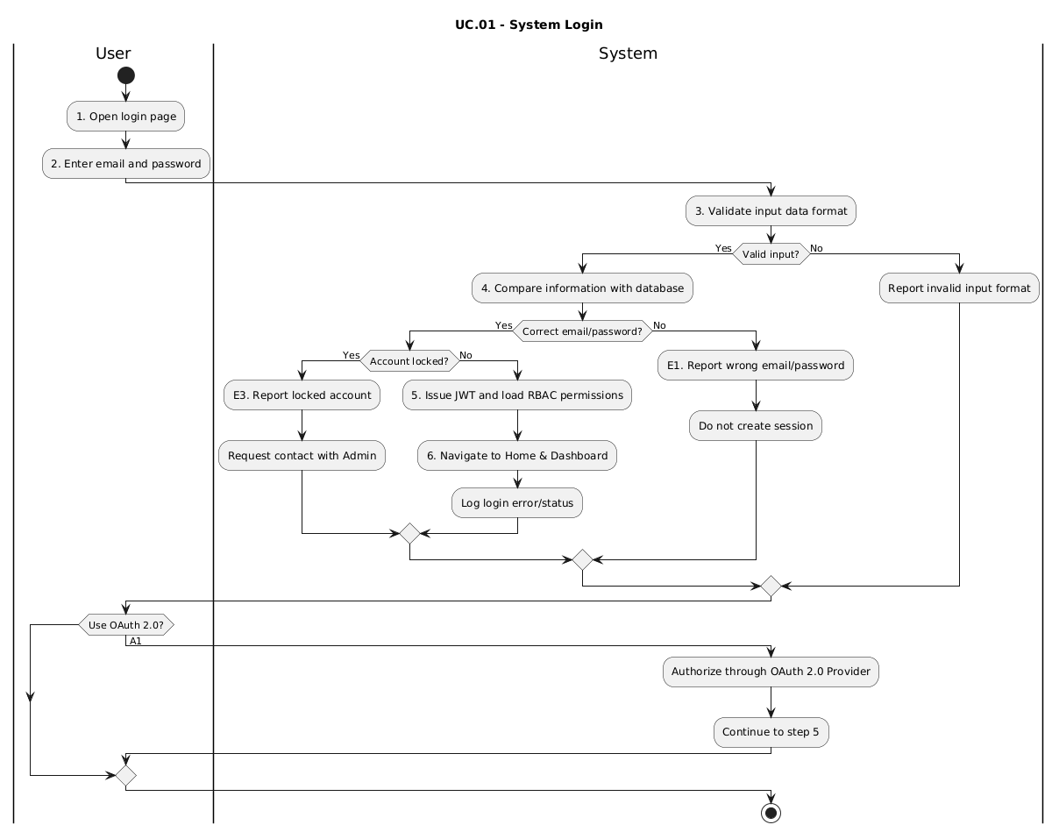
Figure 5.5.1 — Activity Diagram: UC.01 – System Login
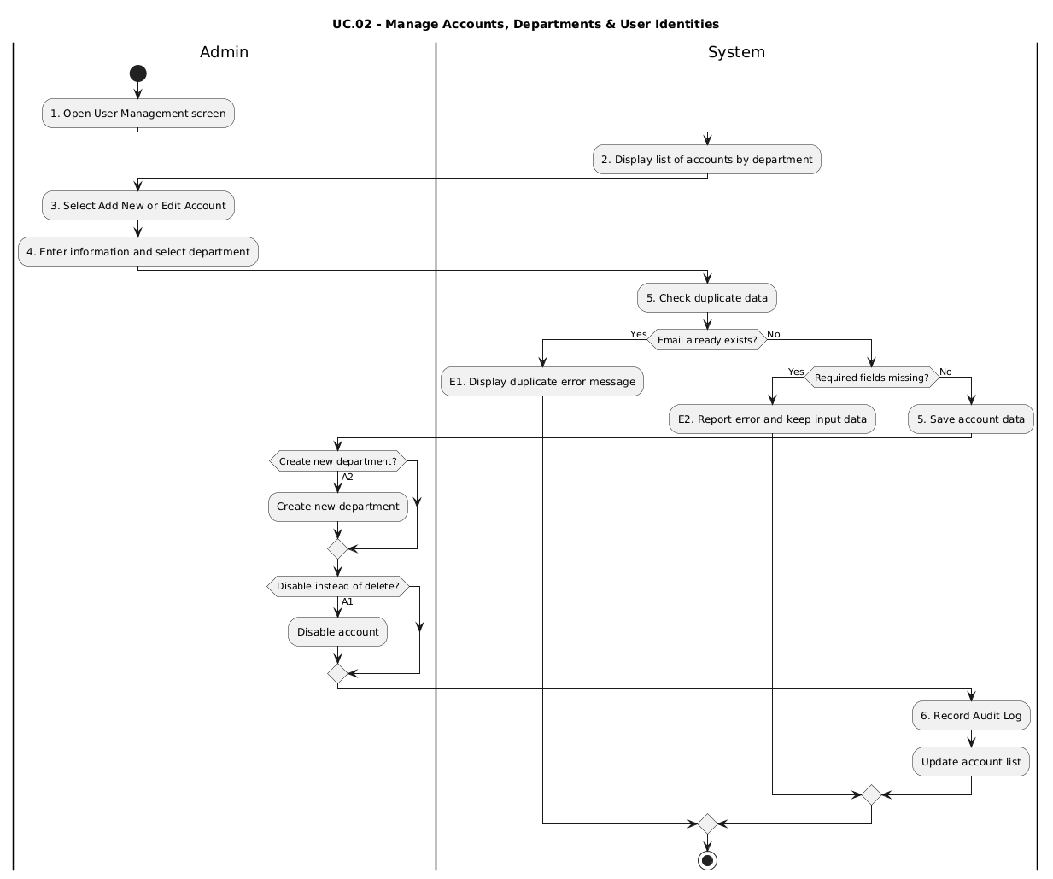
Figure 5.5.2 — Activity Diagram: UC.02 – Manage accounts, departments & user identities
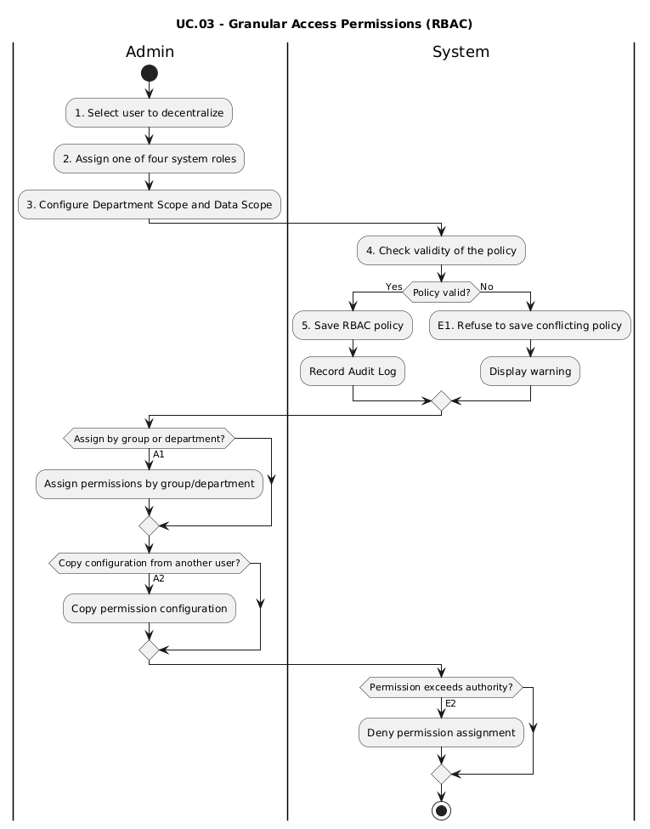
Figure 5.5.3 — Activity Diagram: UC.03 – Granular Access Authorization (RBAC)
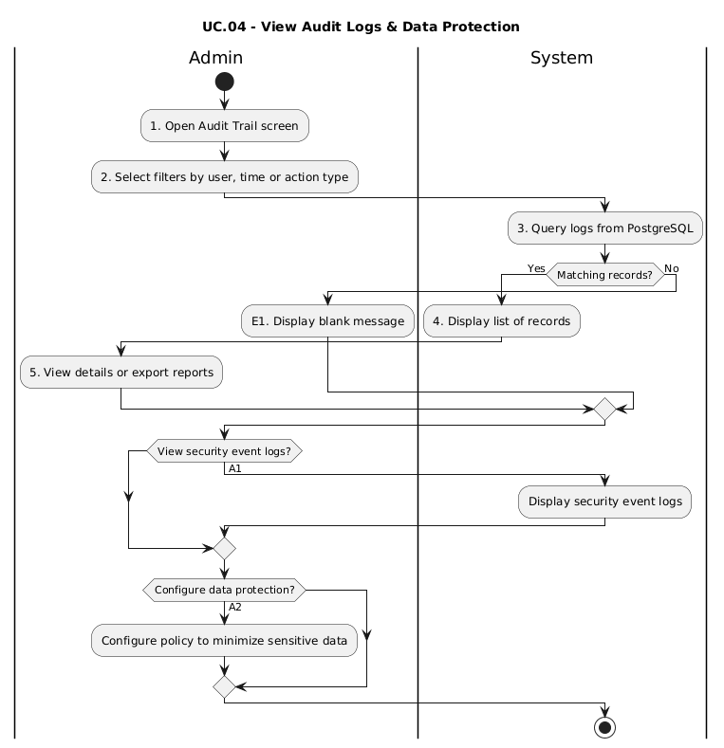
Figure 5.5.4 — Activity Diagram: UC.04 – Audit Log View & Data Protection
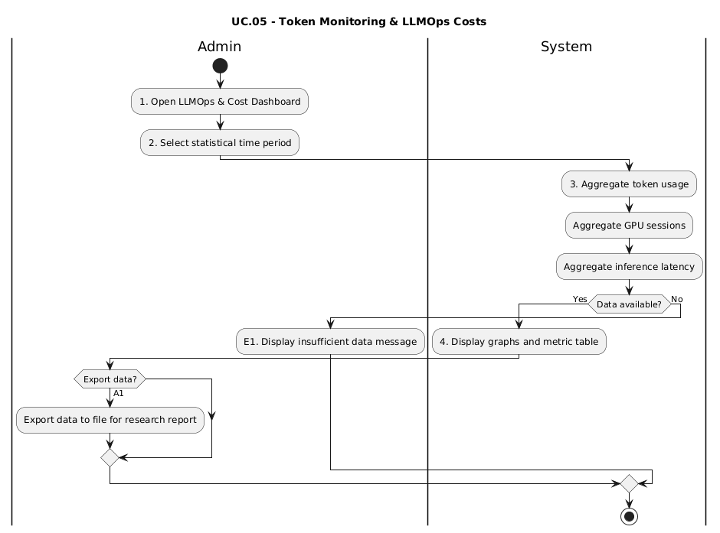
Figure 5.5.5 — Activity Diagram: UC.05 – LLMOps Token & Cost Monitoring
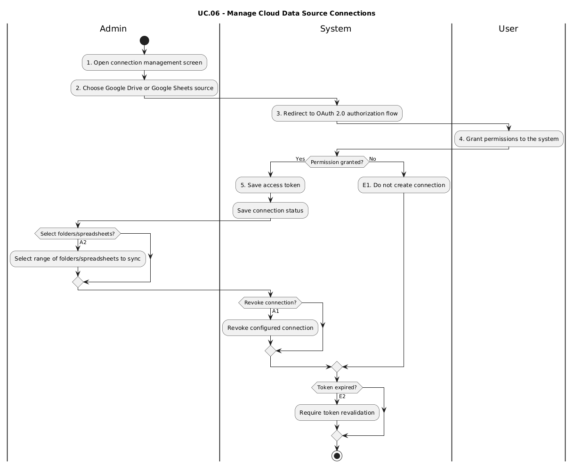
Figure 5.5.6 — Activity Diagram: UC.06 – Cloud Data Source Connection Management
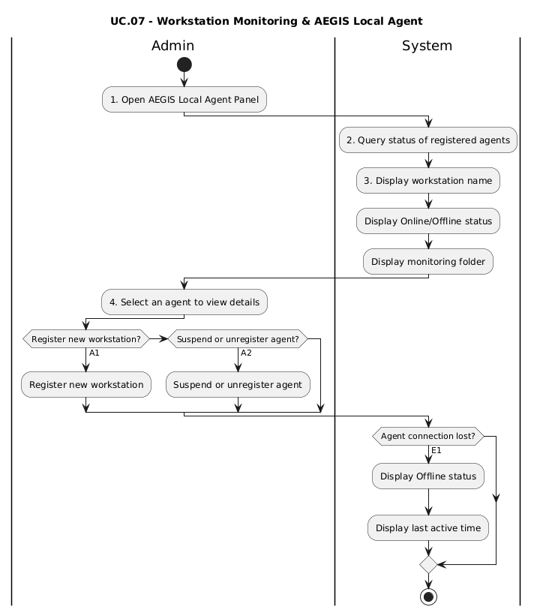
Figure 5.5.7 — Activity Diagram: UC.07 – Workstation Monitoring & AEGIS Local Agent
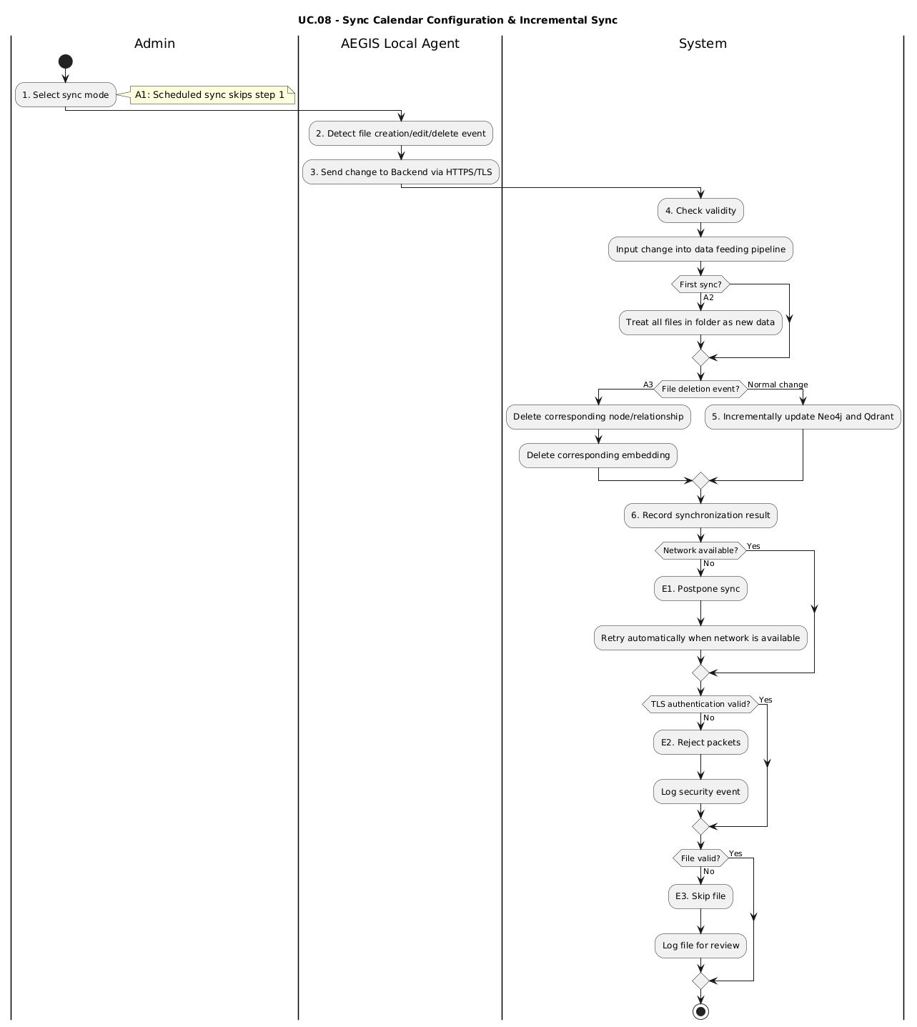
Figure 5.5.8 — Activity Diagram: UC.08 – Sync Calendar Configuration & Incremental Sync
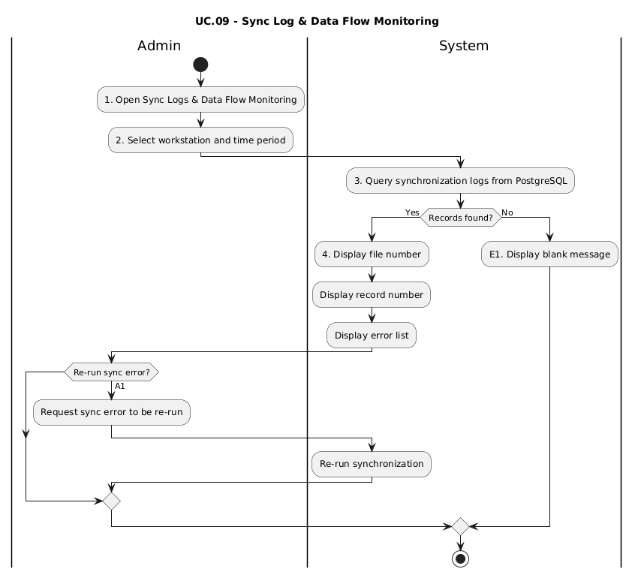
Figure 5.5.9 — Activity Diagram: UC.09 – Sync Log & Data Flow Monitoring
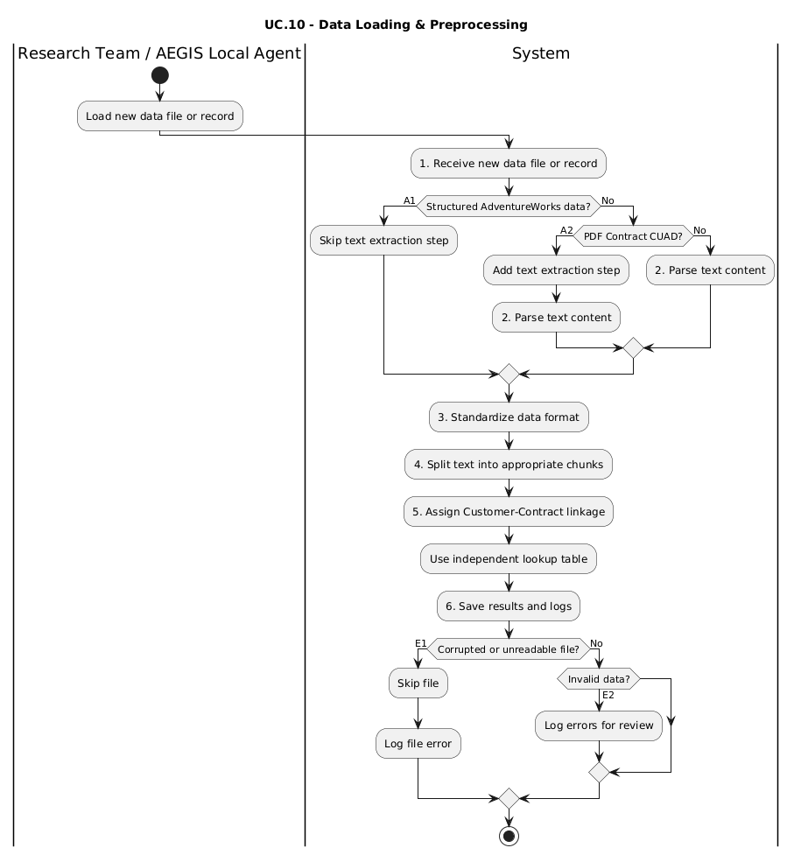
Figure 5.5.10 — Activity Diagram: UC.10 – Data Loading & Preprocessing
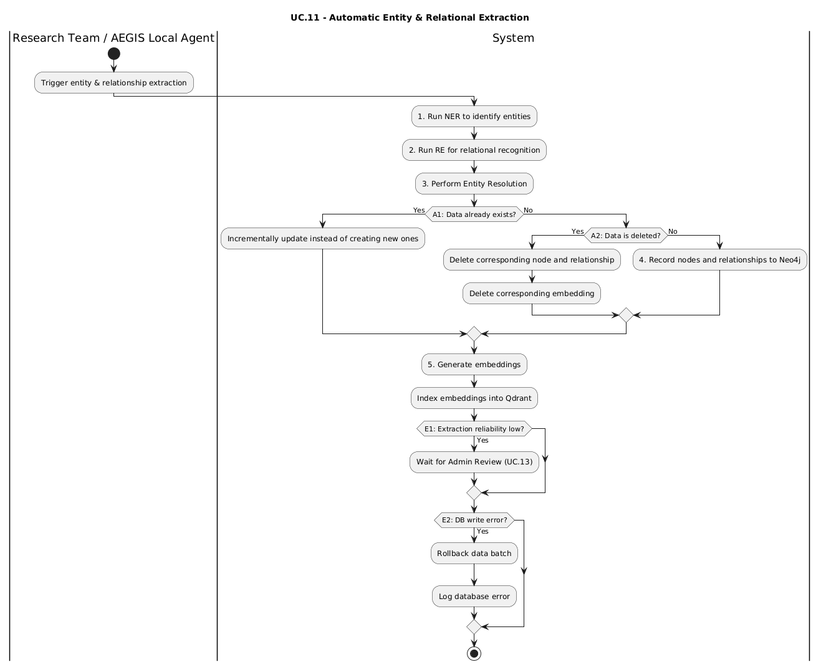
Figure 5.5.11 — Activity Diagram: UC.11 – Automatic Entity & Relational Extraction
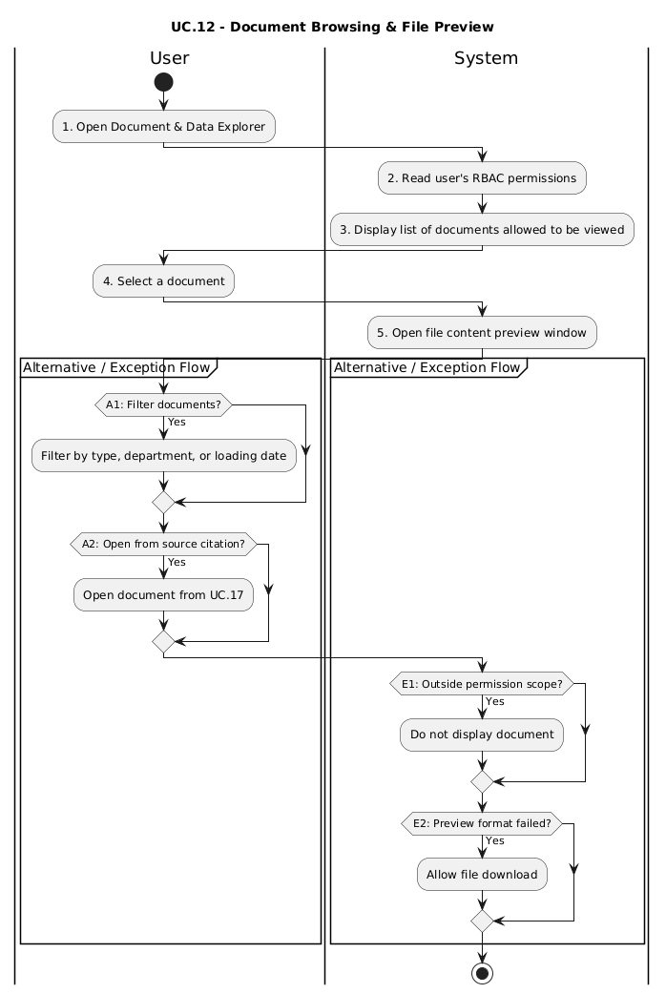
Figure 5.5.12 — Activity Diagram: UC.12 – Document Browsing & File Preview
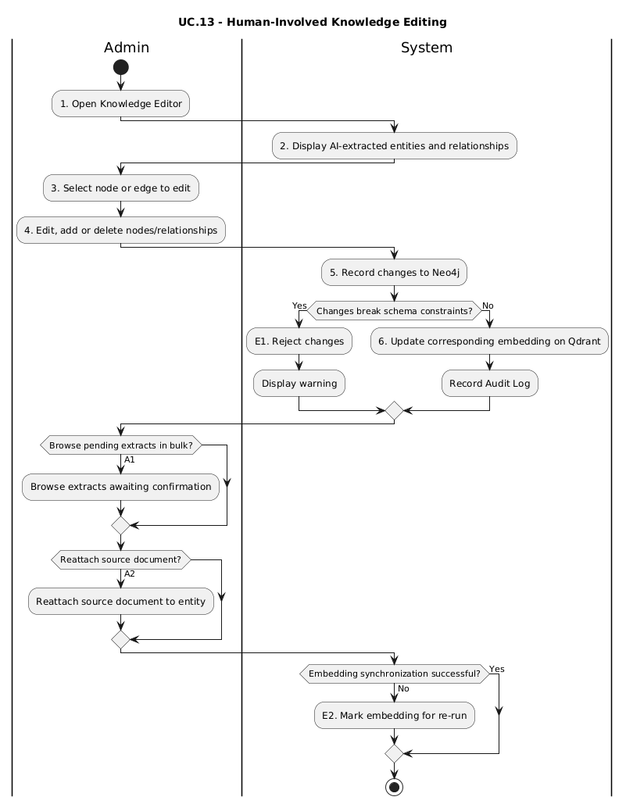
Figure 5.5.13 — Activity Diagram: UC.13 – Human-Involved Knowledge Editing
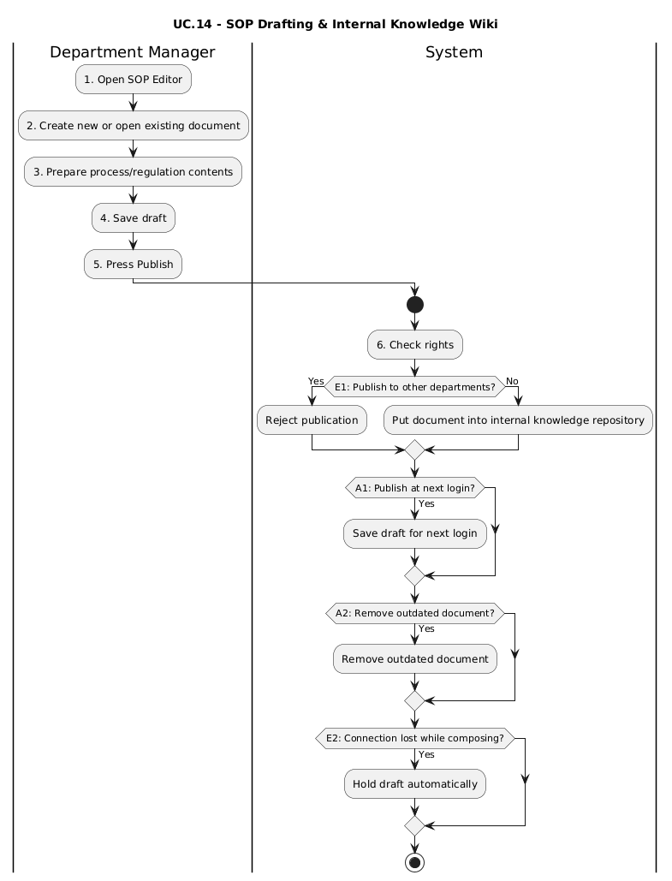
Figure 5.5.14 — Activity Diagram: UC.14 – SOP Drafting & Internal Knowledge Wiki
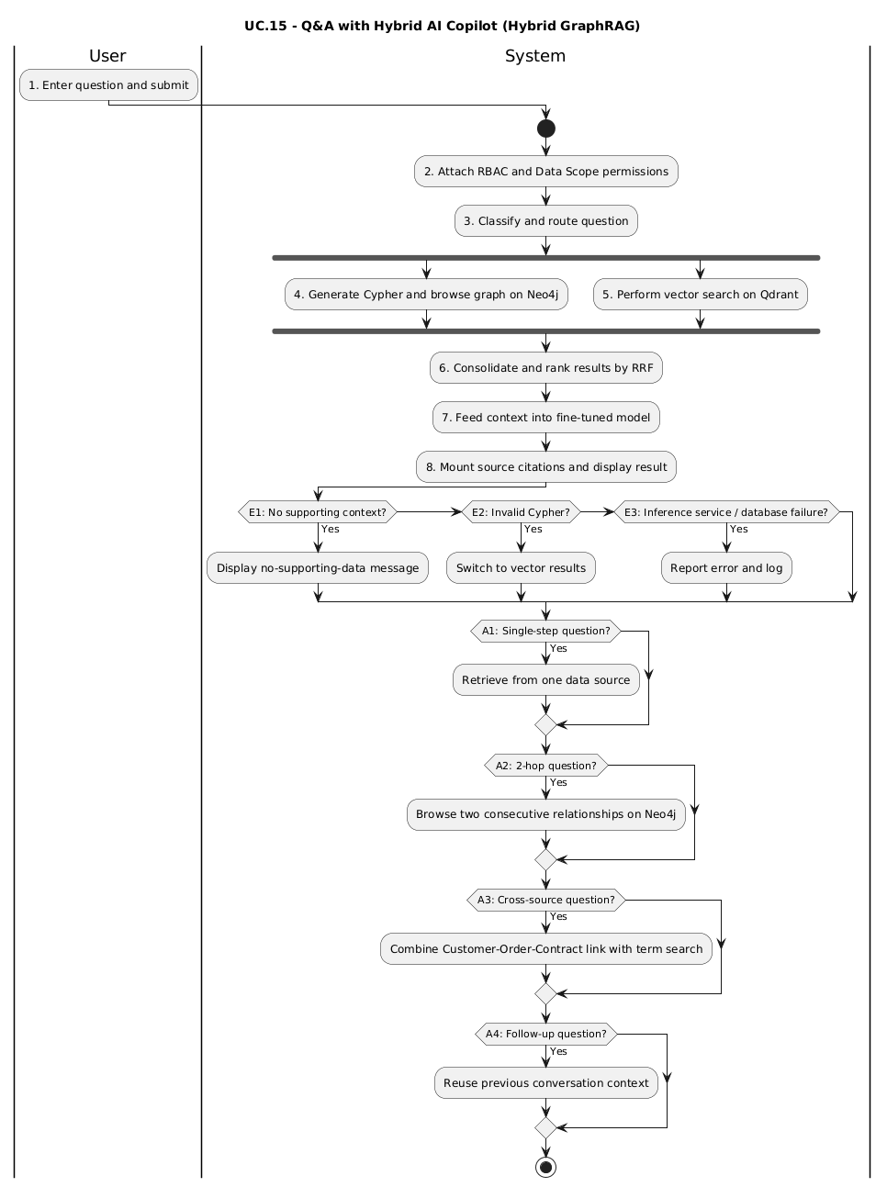
Figure 5.5.15 — Activity Diagram: UC.15 – Q&A with Hybrid AI Copilot (Hybrid GraphRAG)
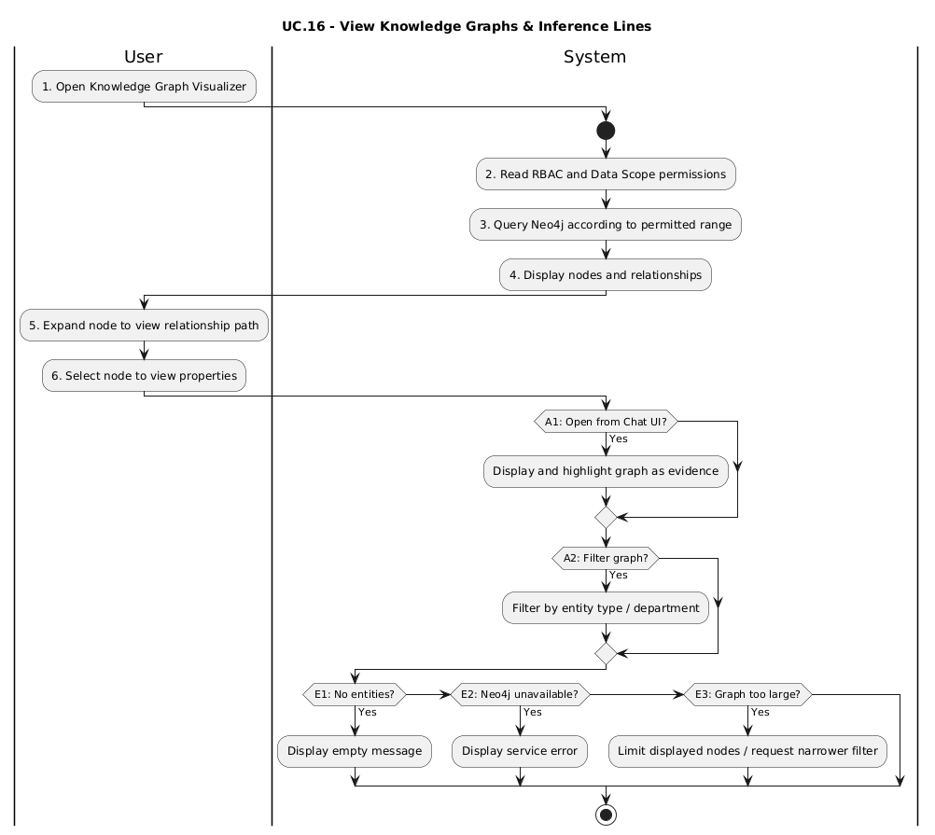
Figure 5.5.16 — Activity Diagram: UC.16 – View Knowledge Graphs & Inference Lines
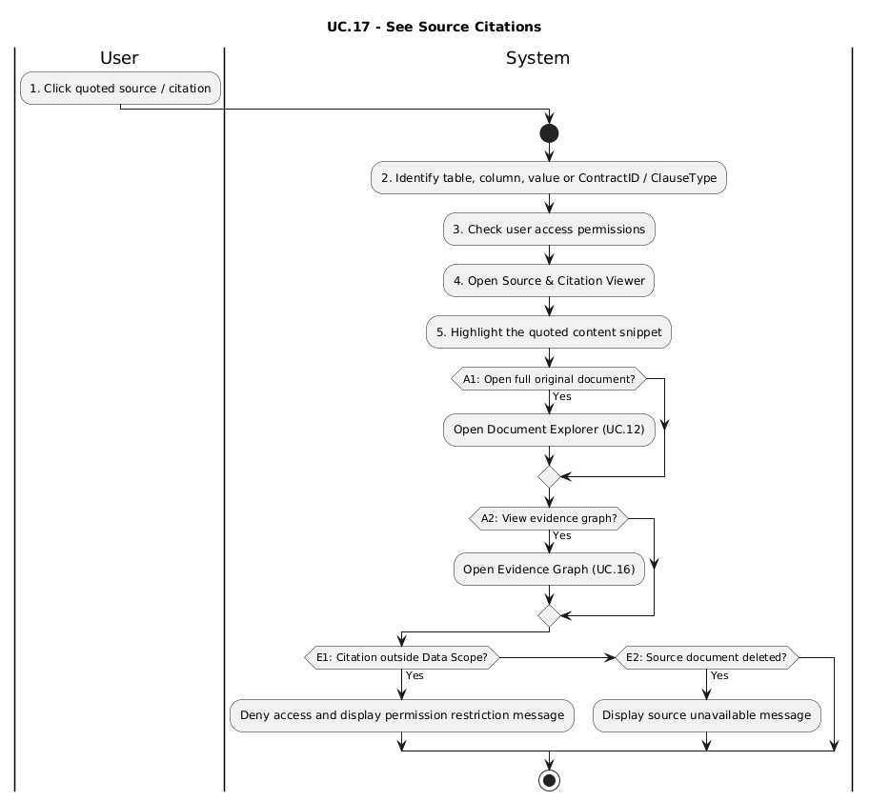
Figure 5.5.17 — Activity Diagram: UC.17 – See source citation
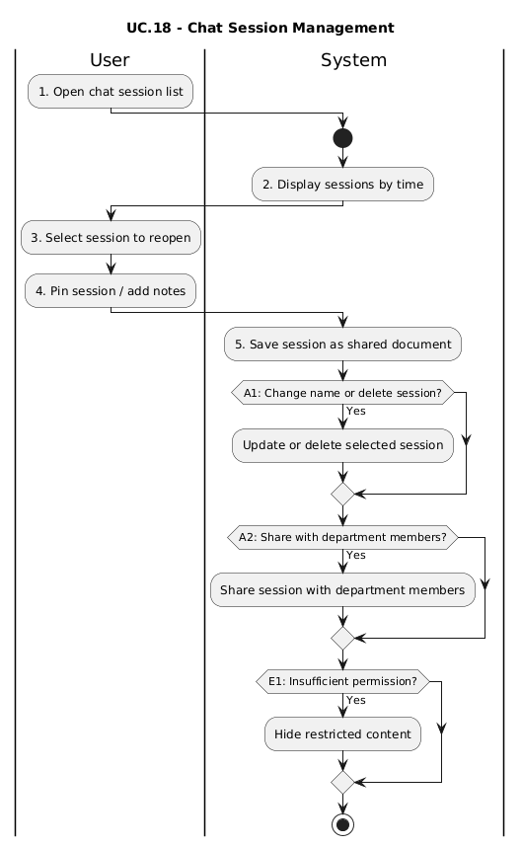
Figure 5.5.18 — Activity Diagram: UC.18 – Chat Session Management & Shared Notes
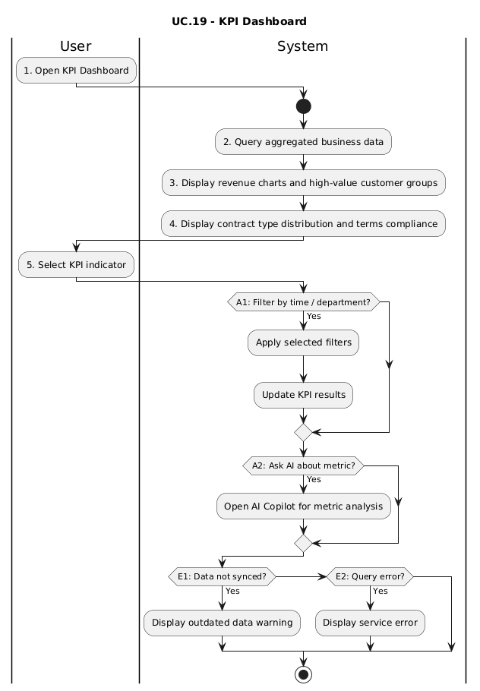
Figure 5.5.19 — Activity Diagram: UC.19 – View Executive KPIs
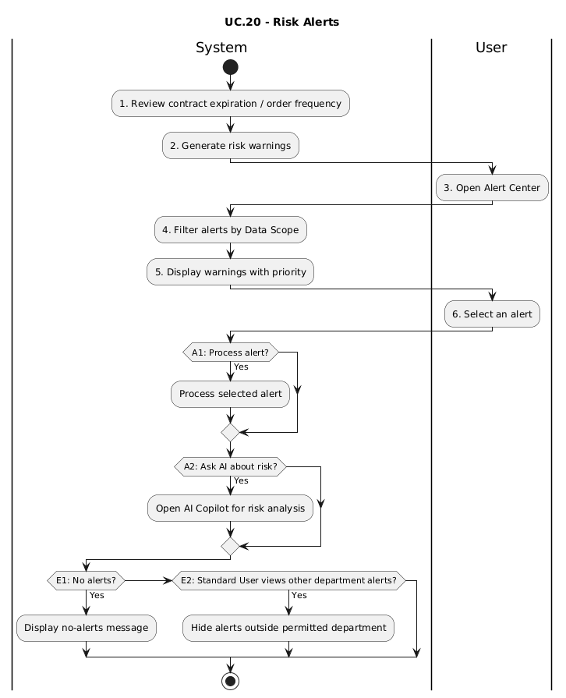
Figure 5.5.20 — Activity Diagram: UC.20 – Intelligent Risk Alert Tracking
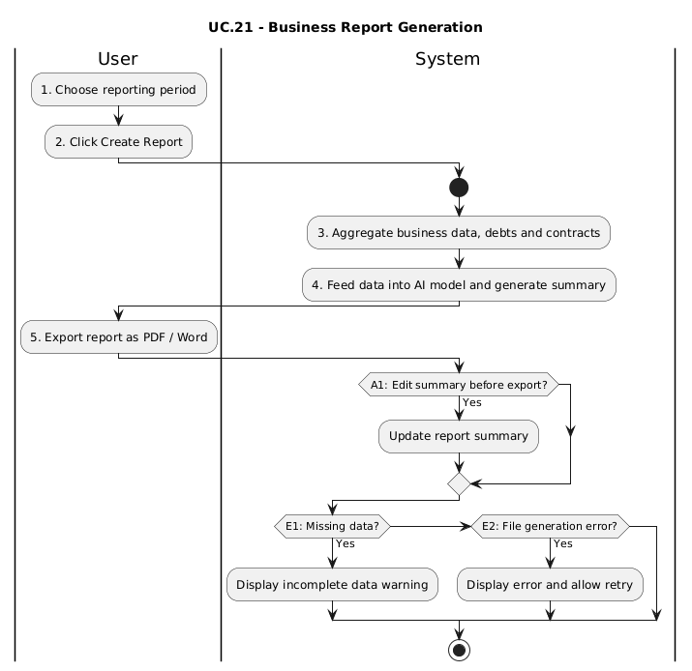
Figure 5.5.21 — Activity Diagram: UC.21 – Automatic Executive Summary Report Generation
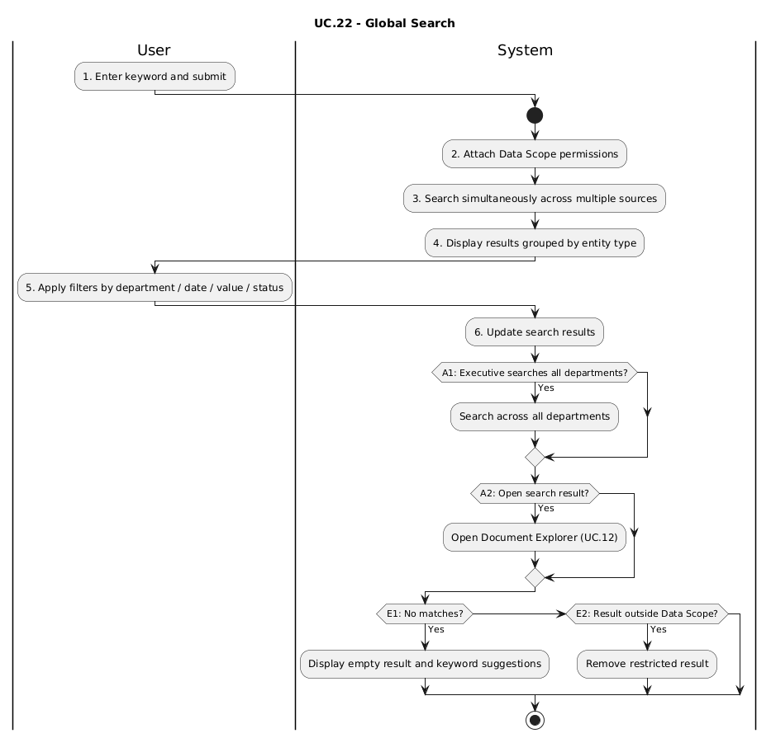
Figure 5.5.22 — Activity Diagram: UC.22 – Multifaceted Unified Search & Filtering

5.6 Sequence Diagram
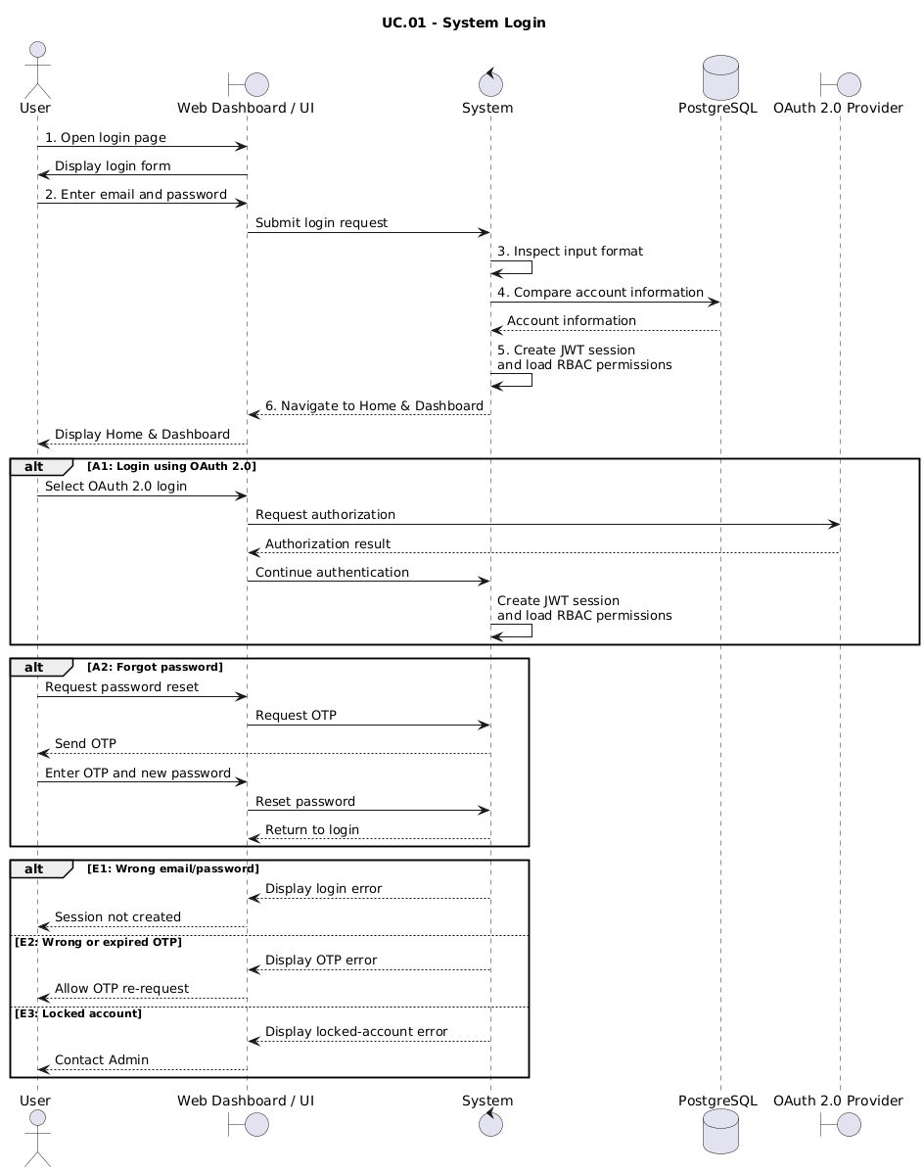
Figure 5.6.1 — Sequence Diagram: UC.01 – System Login
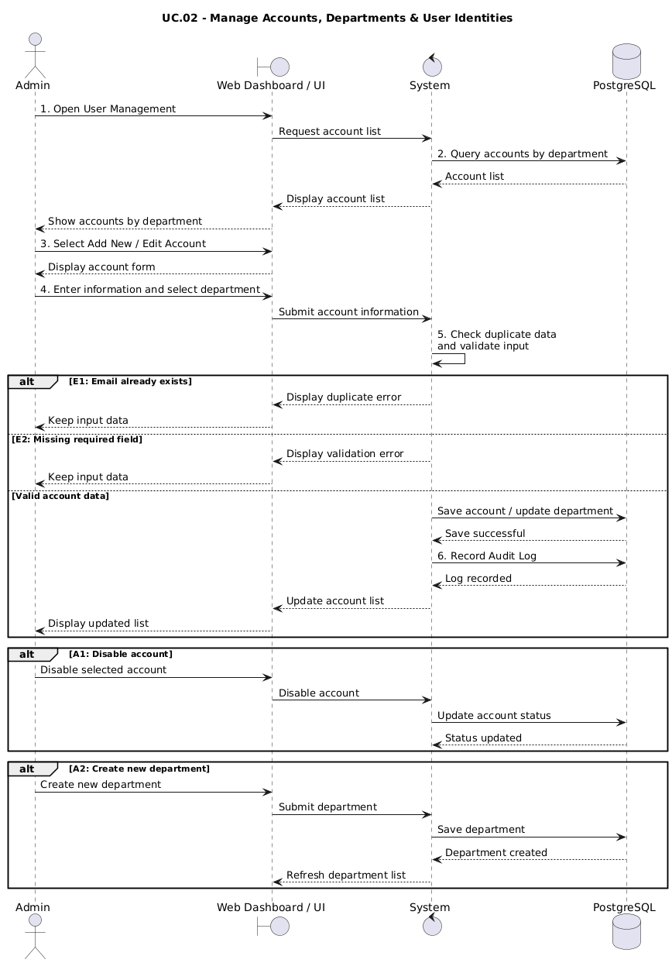
Figure 5.6.2 — Sequence Diagram: UC.02 – Manage accounts, departments & user identities
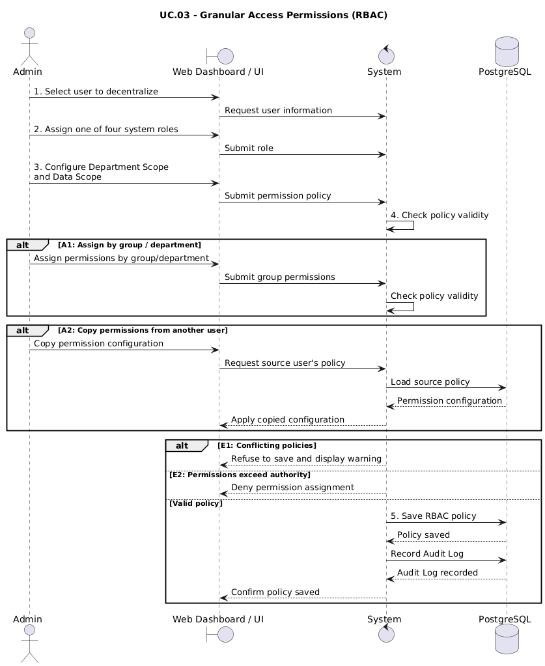
Figure 5.6.3 — Sequence Diagram: UC.03 – Granular Access Authorization (RBAC)
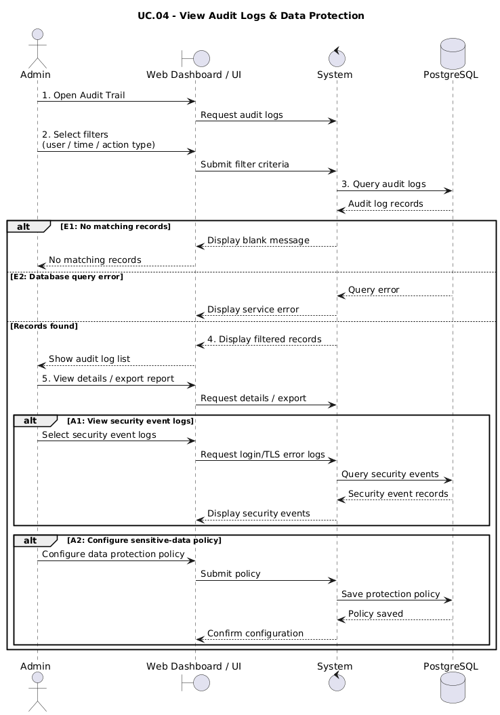
Figure 5.6.4 — Sequence Diagram: UC.04 – Audit Log View & Data Protection
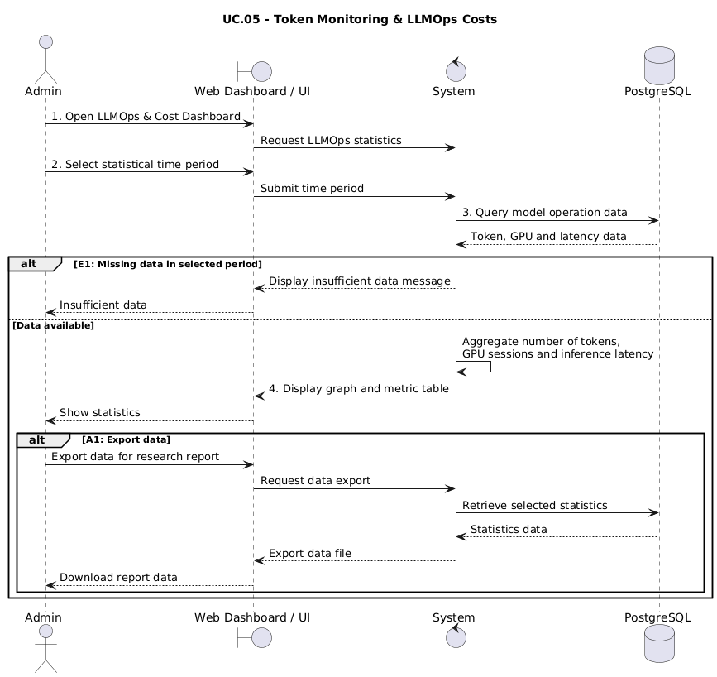
Figure 5.6.5 — Sequence Diagram: UC.05 – LLMOps Token & Cost Monitoring
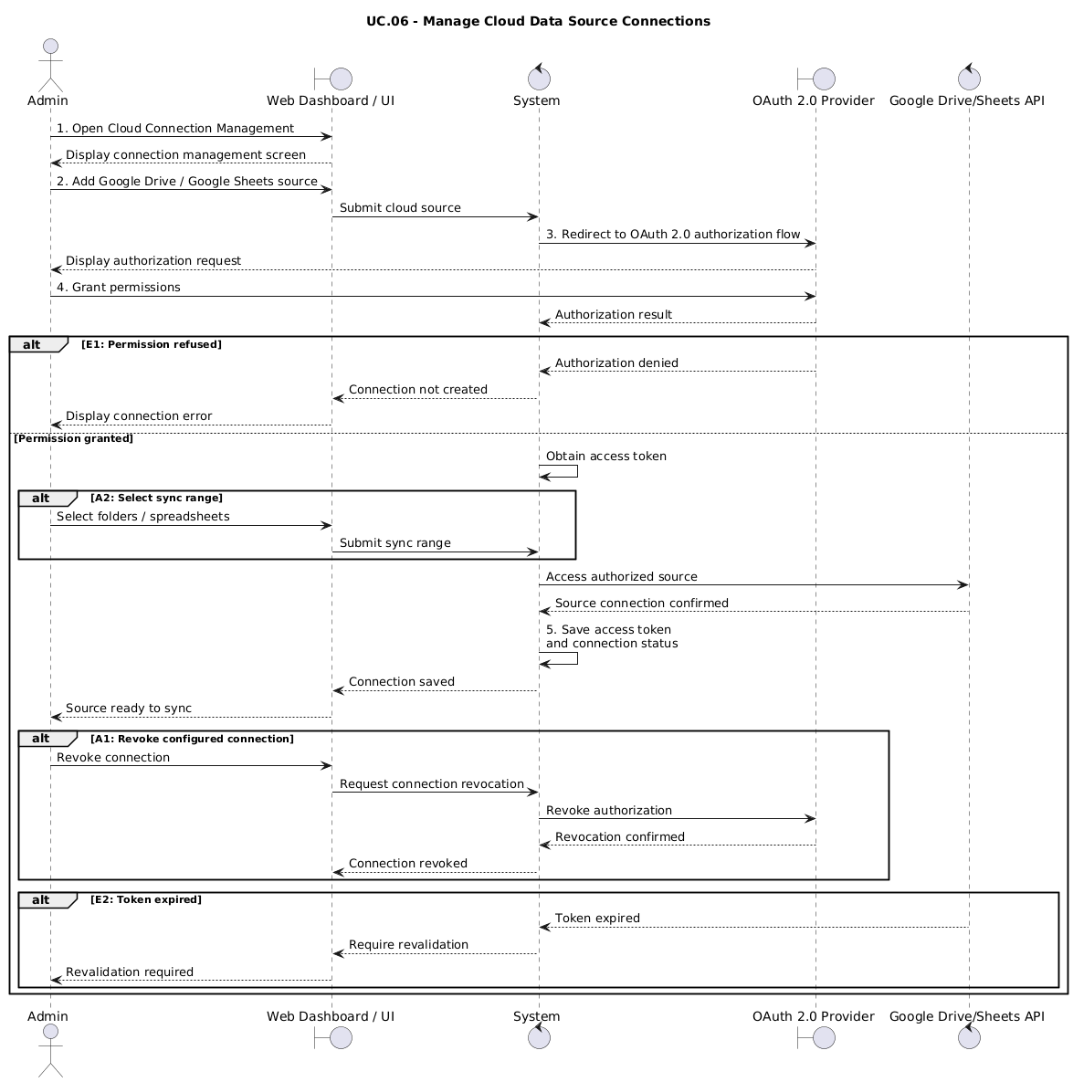
Figure 5.6.6 — Sequence Diagram: UC.06 – Cloud Data Source Connection Management
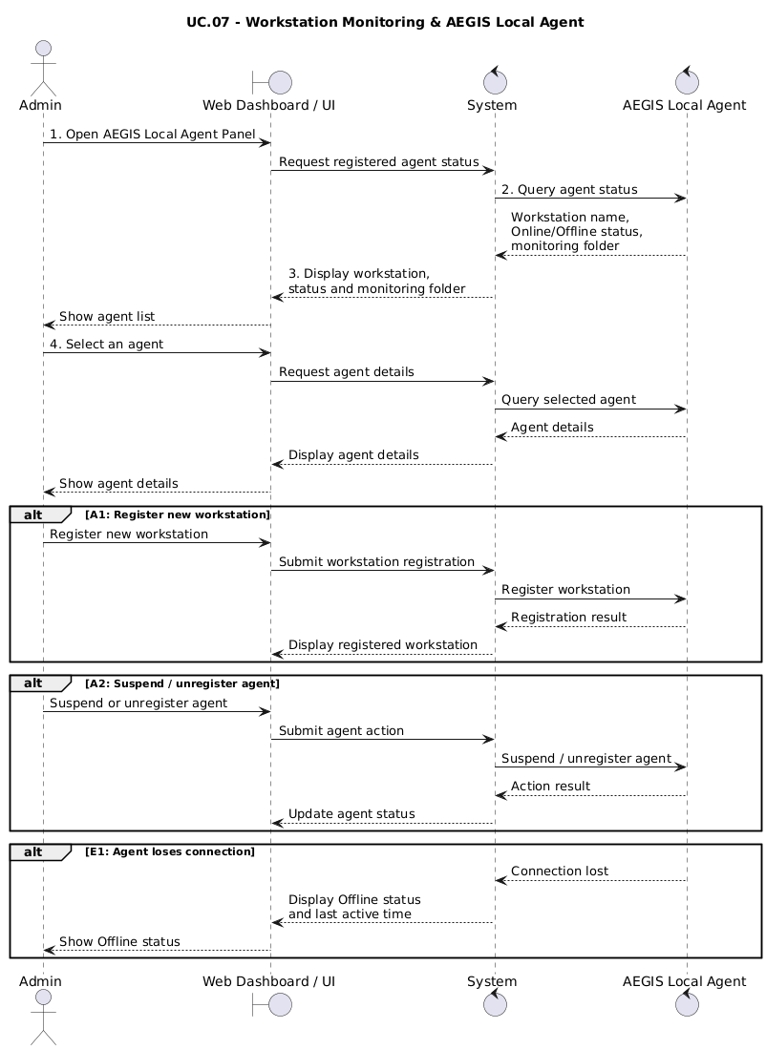
Figure 5.6.7 — Sequence Diagram: UC.07 – Workstation Monitoring & AEGIS Local Agent
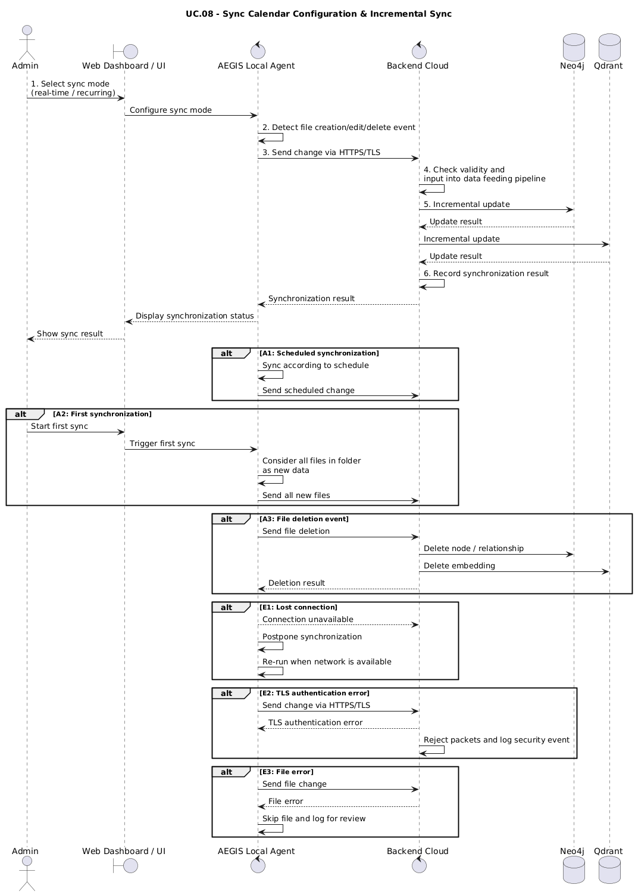
Figure 5.6.8 — Sequence Diagram: UC.08 – Sync Calendar Configuration & Incremental Sync
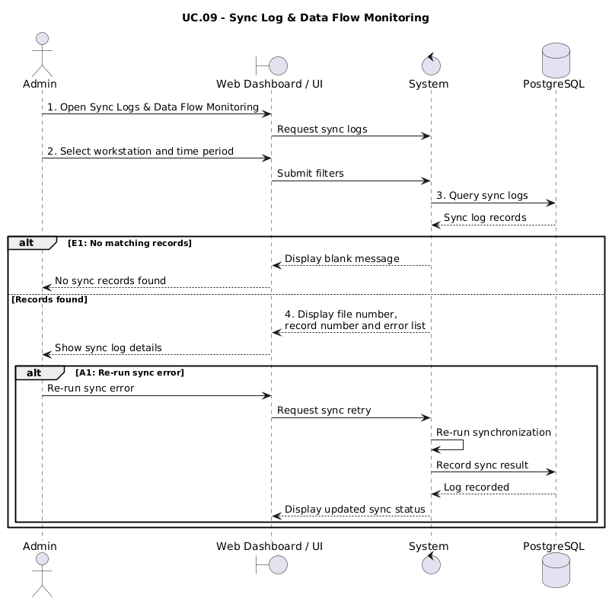
Figure 5.6.9 — Sequence Diagram: UC.09 – Sync Log & Data Flow Monitoring
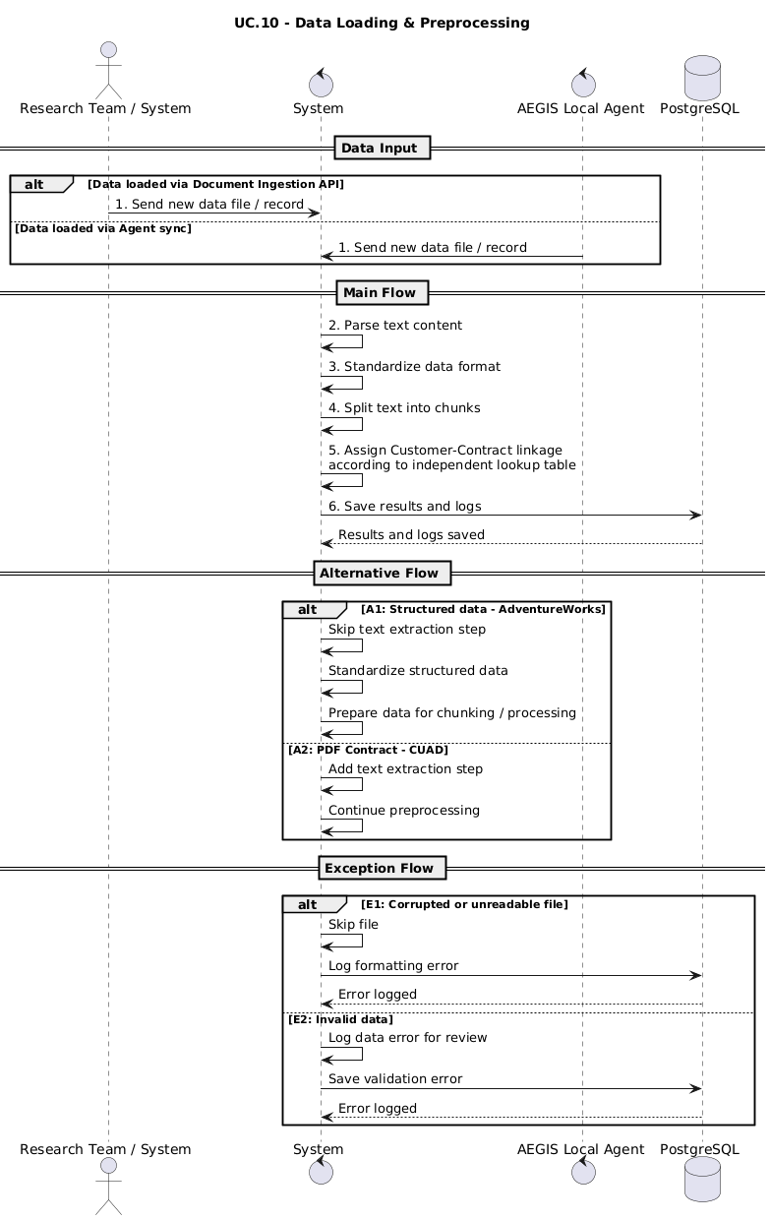
Figure 5.6.10 — Sequence Diagram: UC.10 – Data Loading & Preprocessing
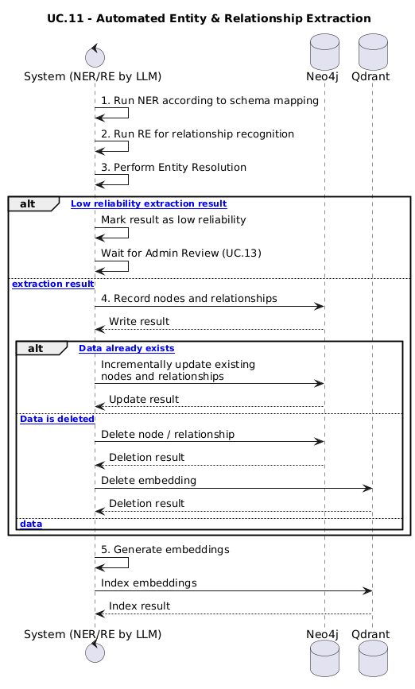
Figure 5.6.11 — Sequence Diagram: UC.11 – Automatic Entity & Relational Extraction
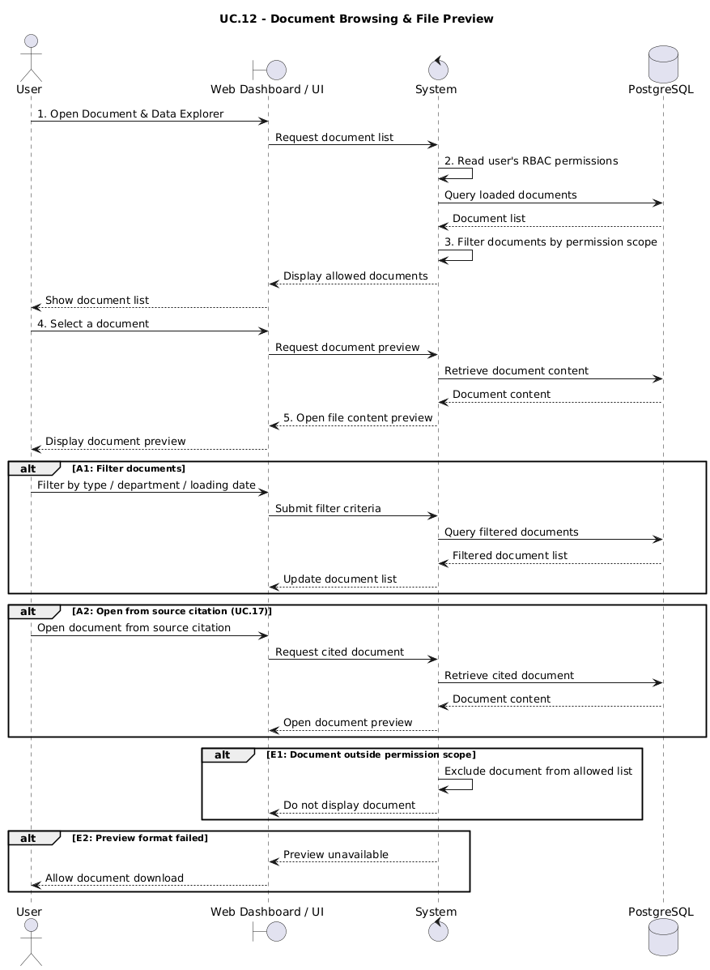
Figure 5.6.12 — Sequence Diagram: UC.12 – Document Browsing & File Preview
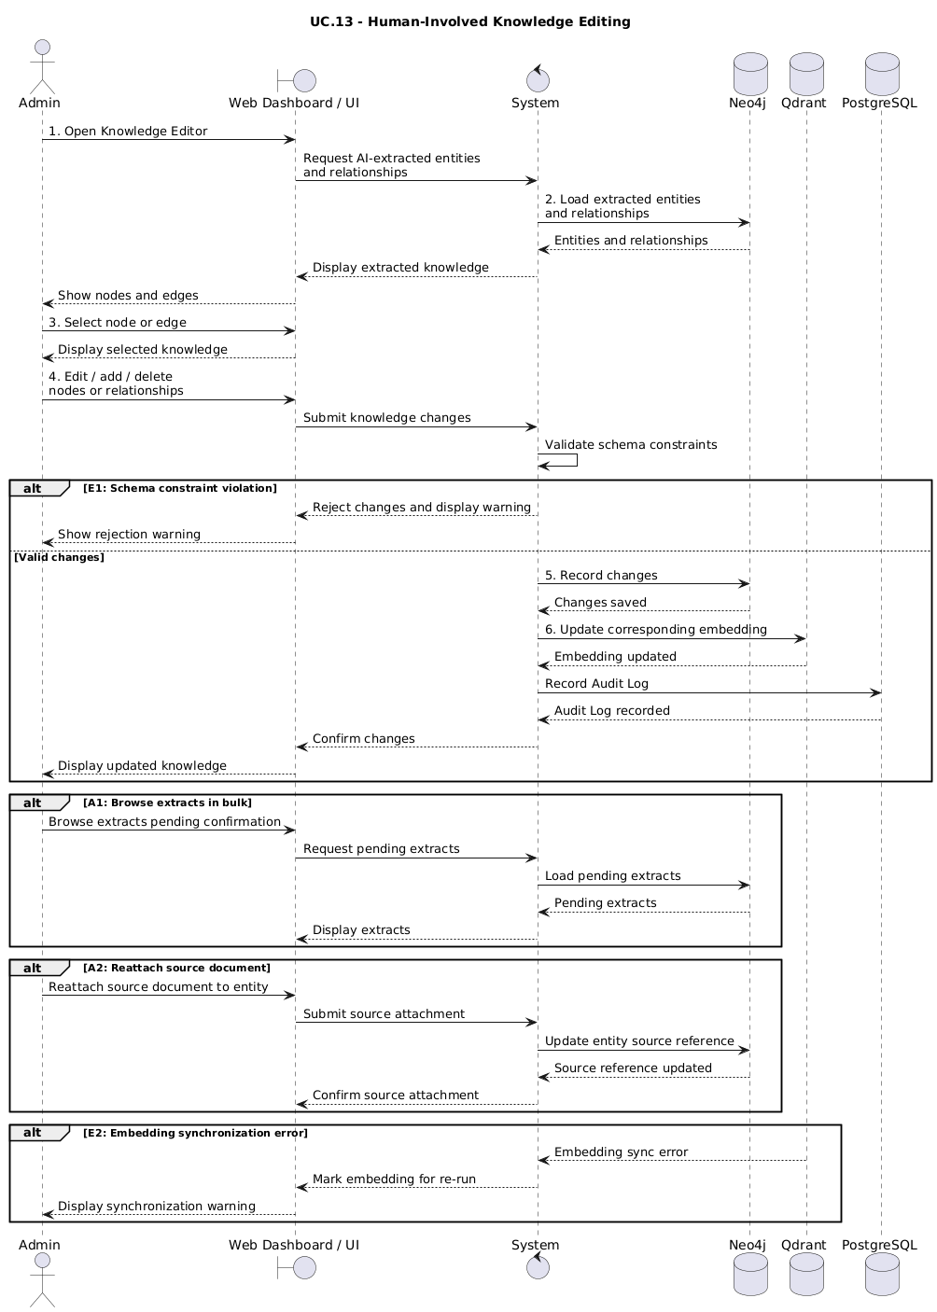
Figure 5.6.13 — Sequence Diagram: UC.13 – Human-Involved Knowledge Editing
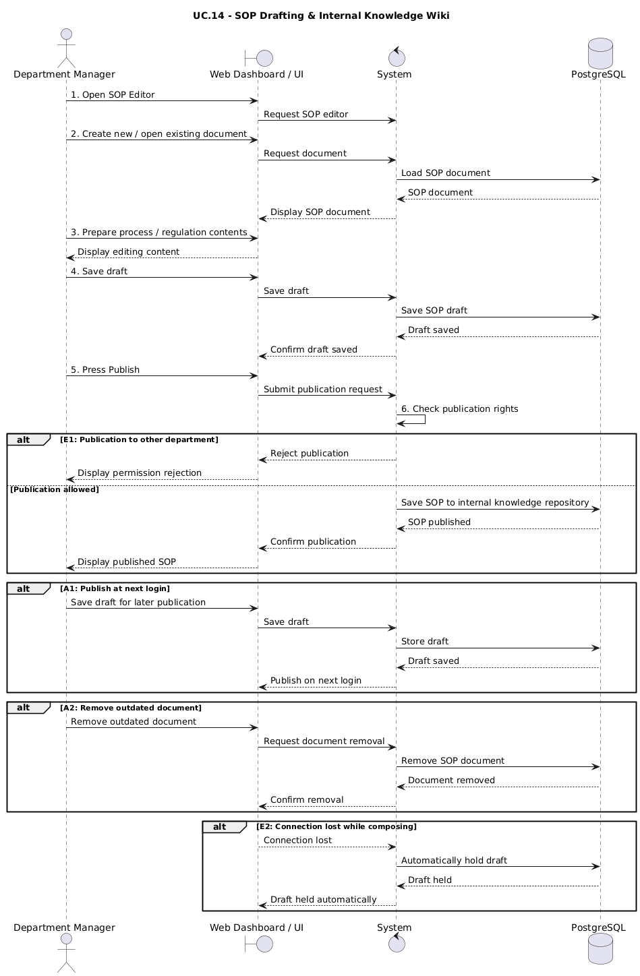
Figure 5.6.14 — Sequence Diagram: UC.14 – SOP Drafting & Internal Knowledge Wiki
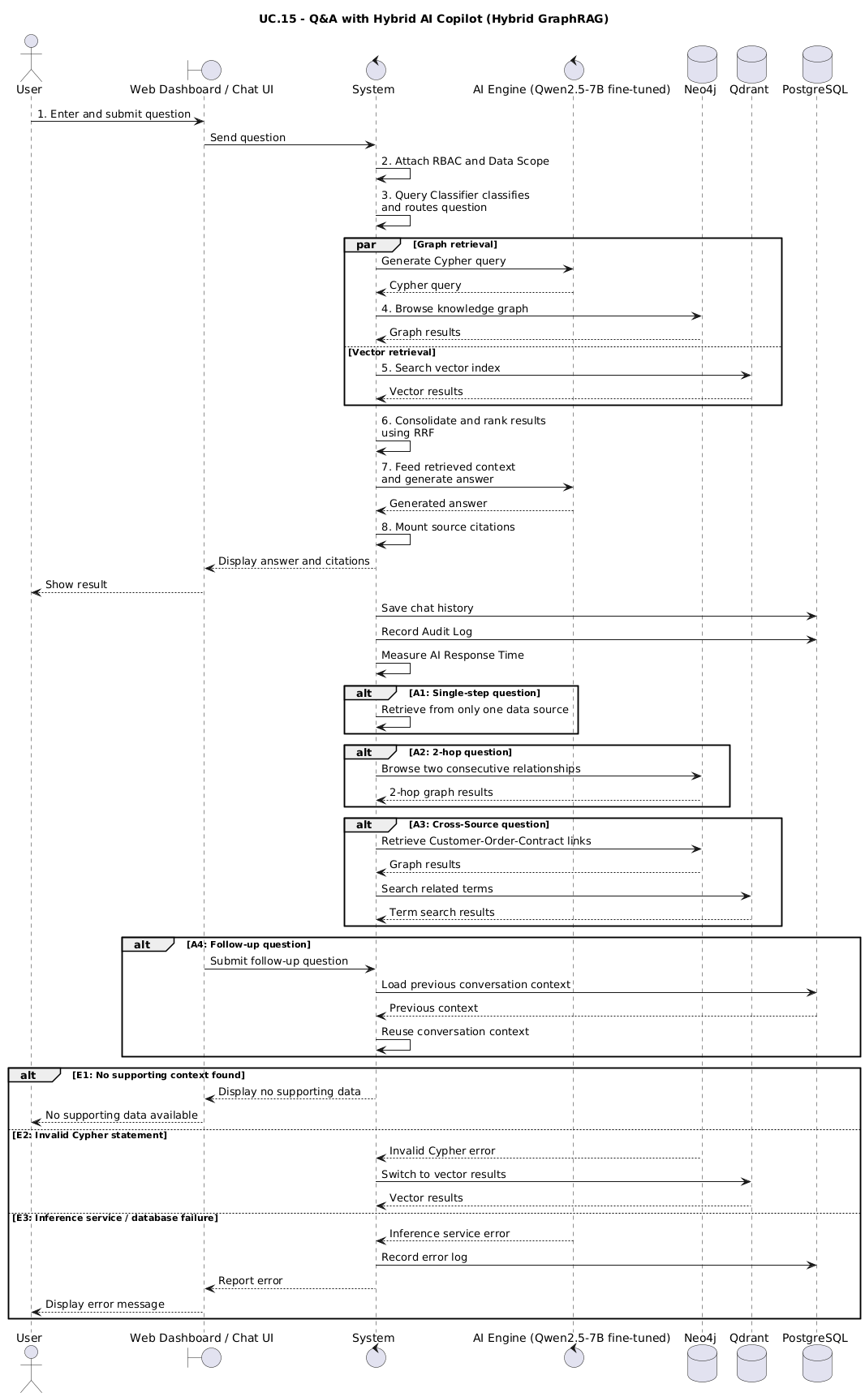
Figure 5.6.15 — Sequence Diagram: UC.15 – Q&A with Hybrid AI Copilot (Hybrid GraphRAG)
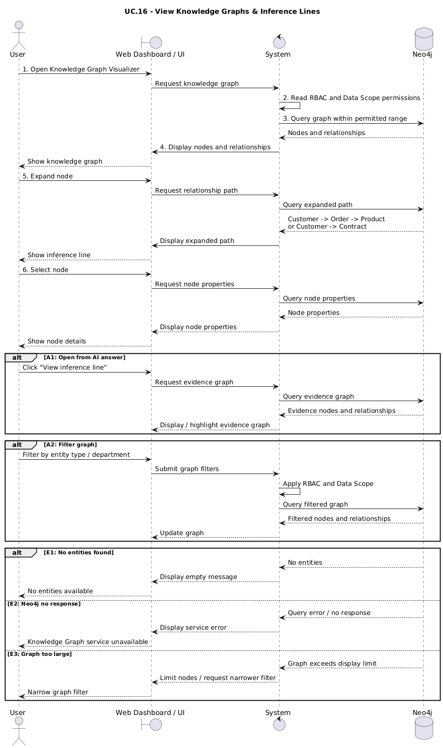
Figure 5.6.16 — Sequence Diagram: UC.16 – View Knowledge Graphs & Inference Lines
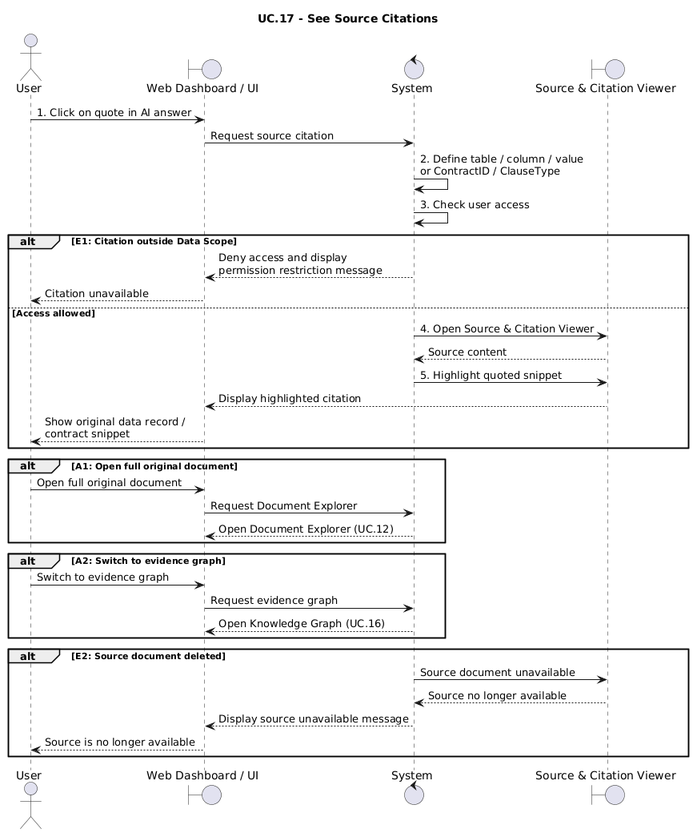
Figure 5.6.17 — Sequence Diagram: UC.17 – See source citation
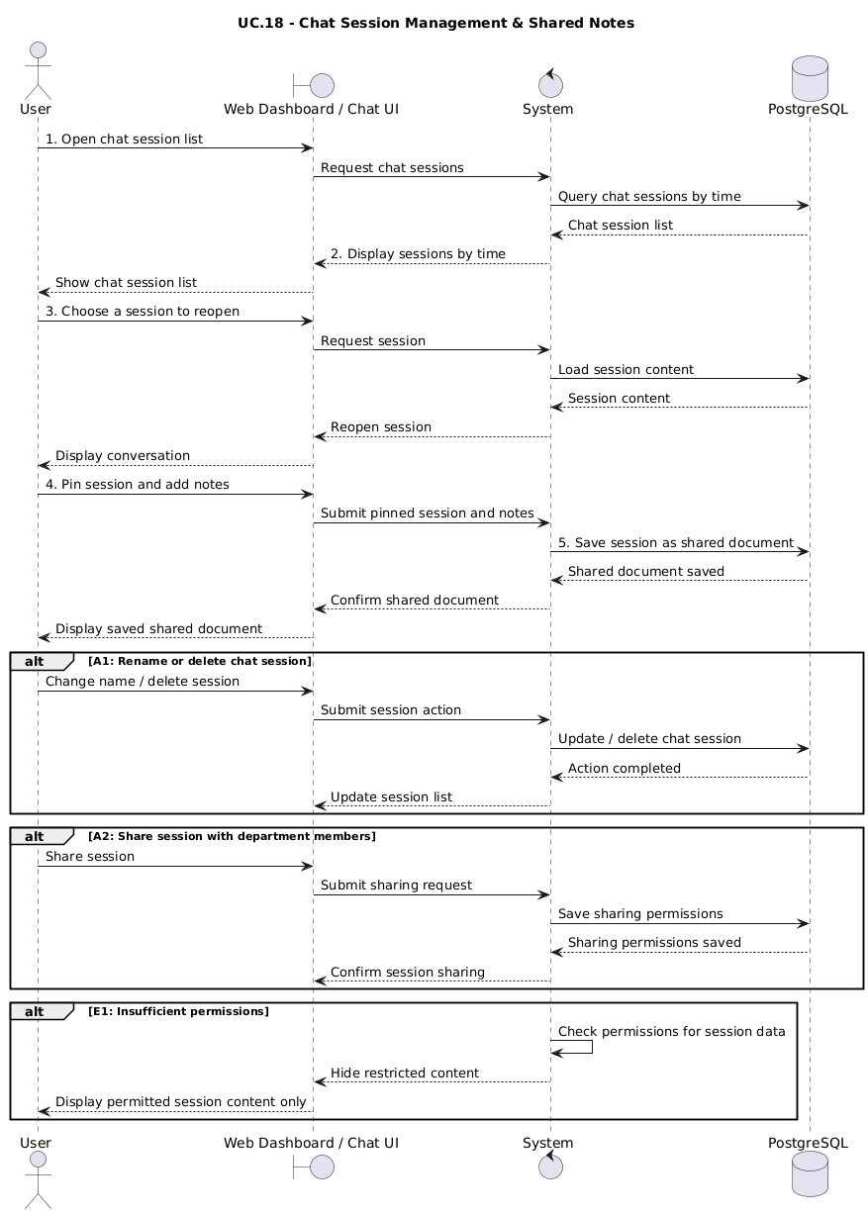
Figure 5.6.18 — Sequence Diagram: UC.18 – Chat Session Management & Shared Notes
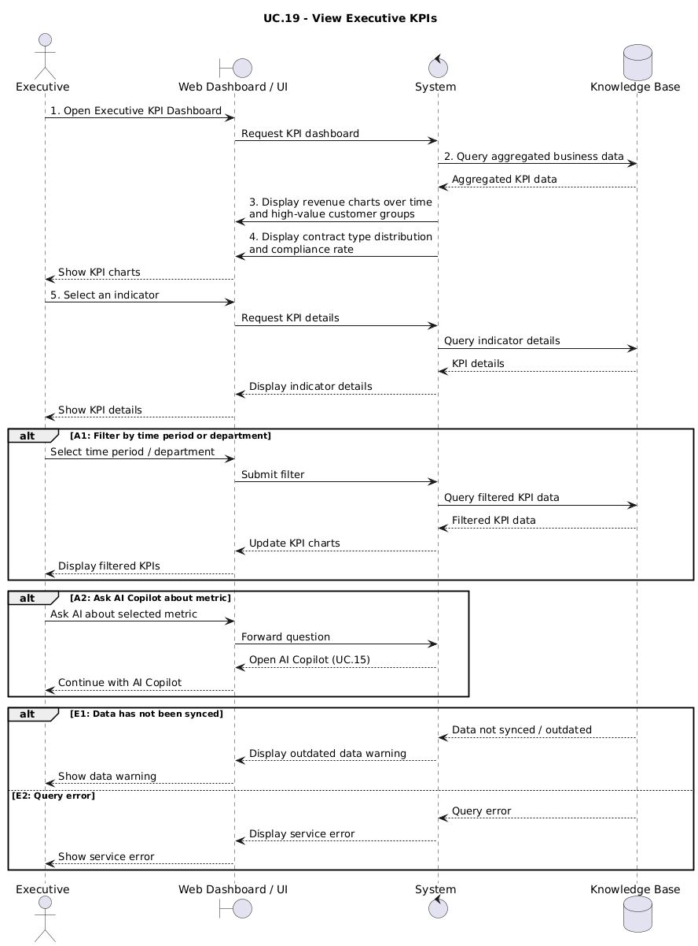
Figure 5.6.19 — Sequence Diagram: UC.19 – View Executive KPIs
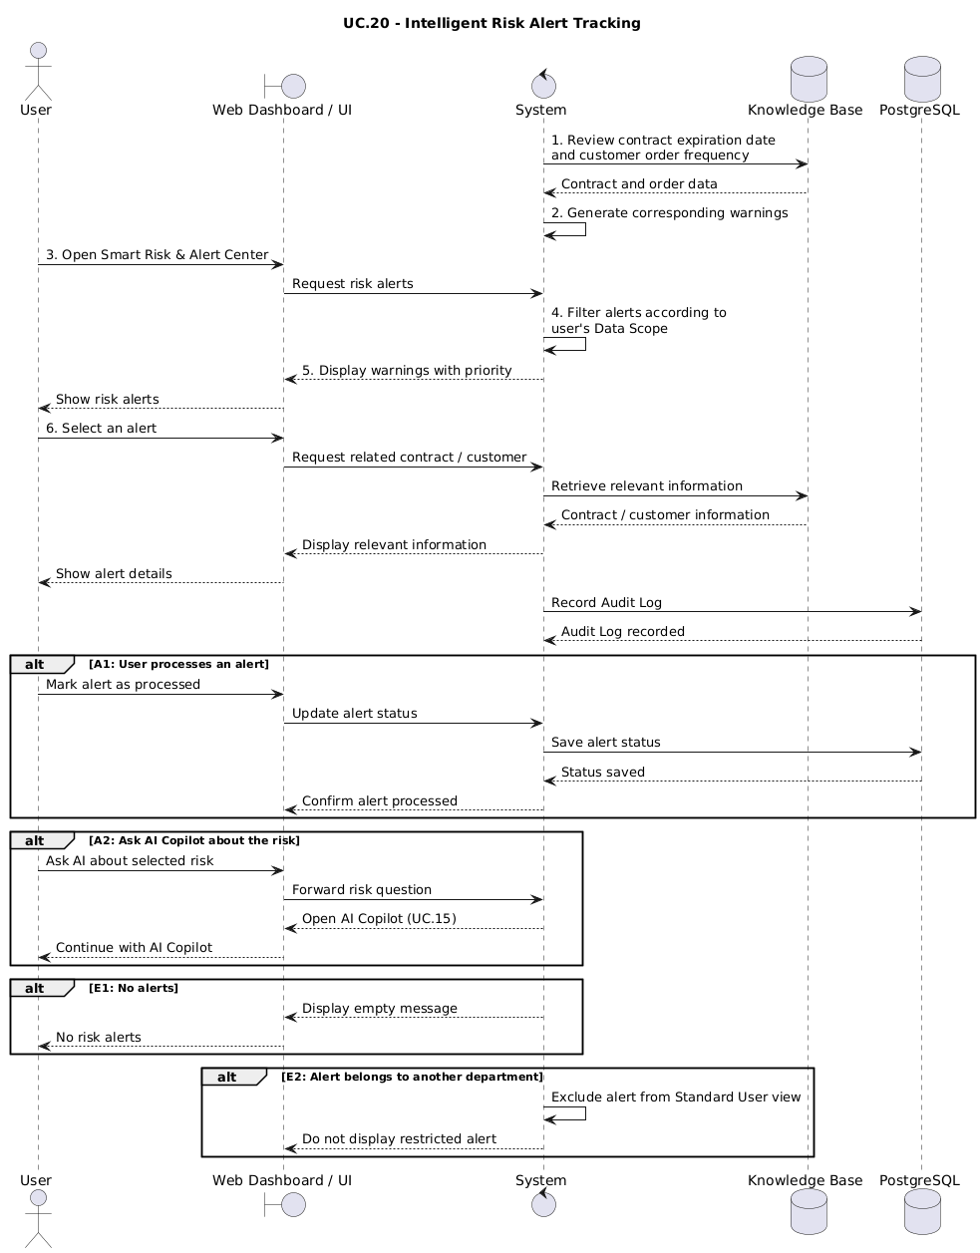
Figure 5.6.20 — Sequence Diagram: UC.20 – Intelligent Risk Alert Tracking
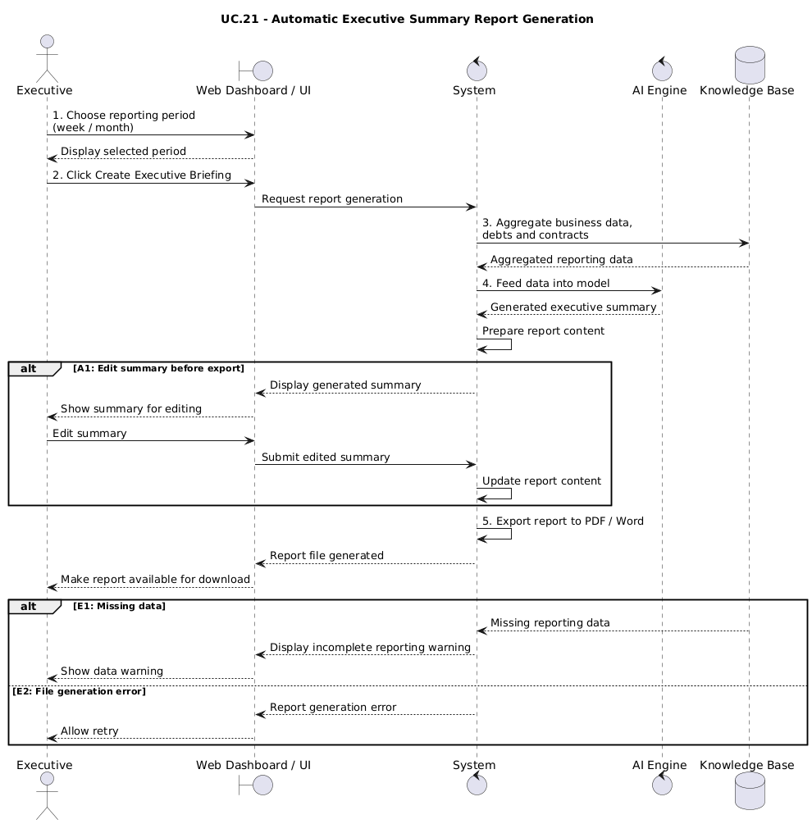
Figure 5.6.21 — Sequence Diagram: UC.21 – Automatic Executive Summary Report Generation
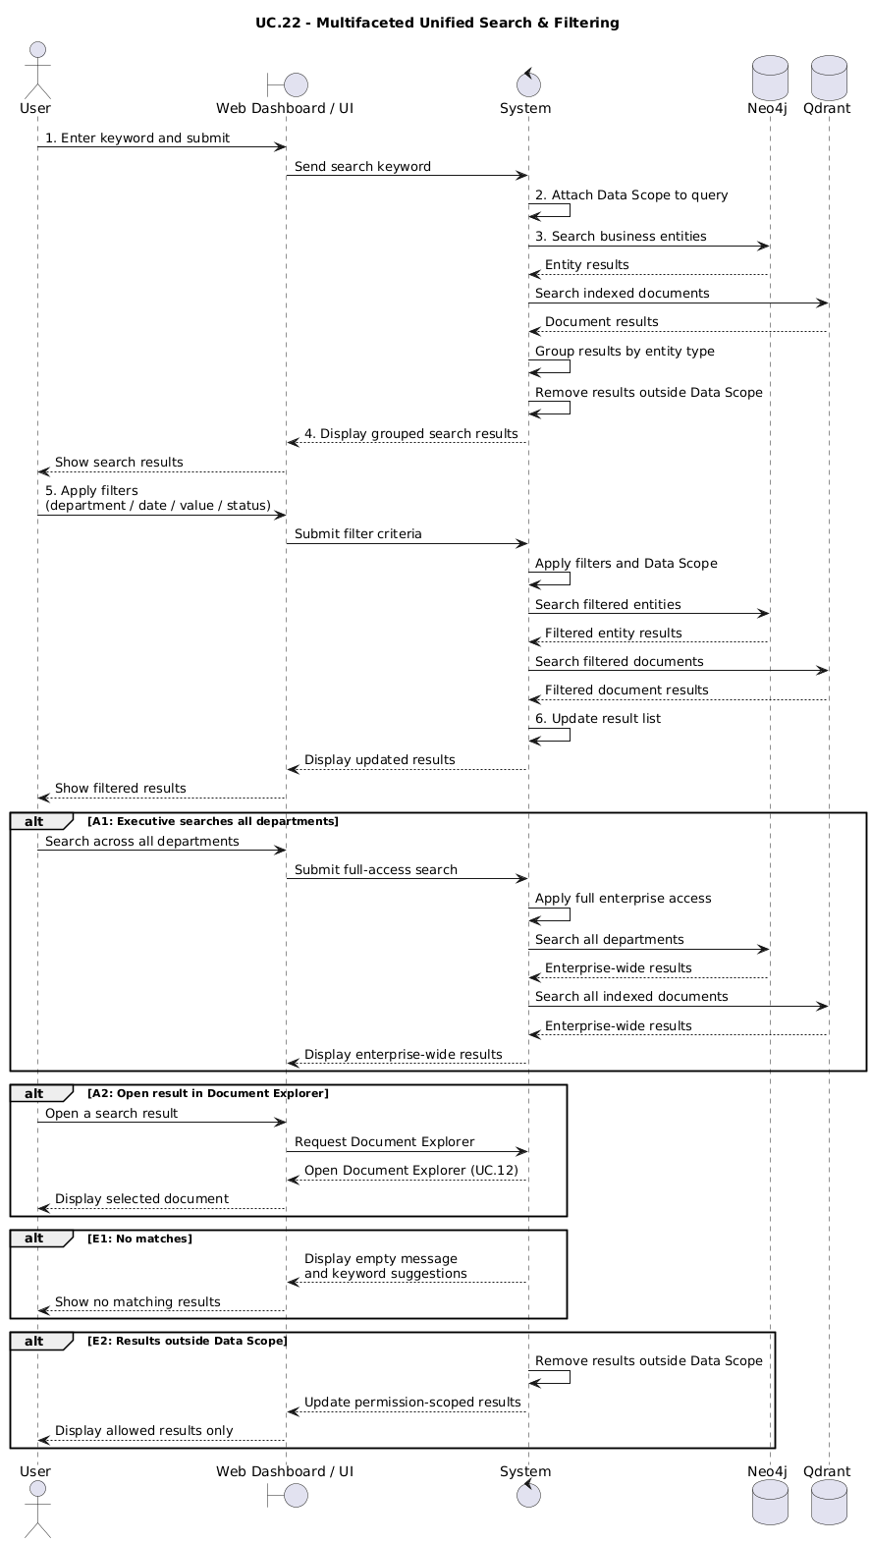
Figure 5.6.22 — Sequence Diagram: UC.22 – Multifaceted Unified Search & Filtering

5.7 Class Diagram
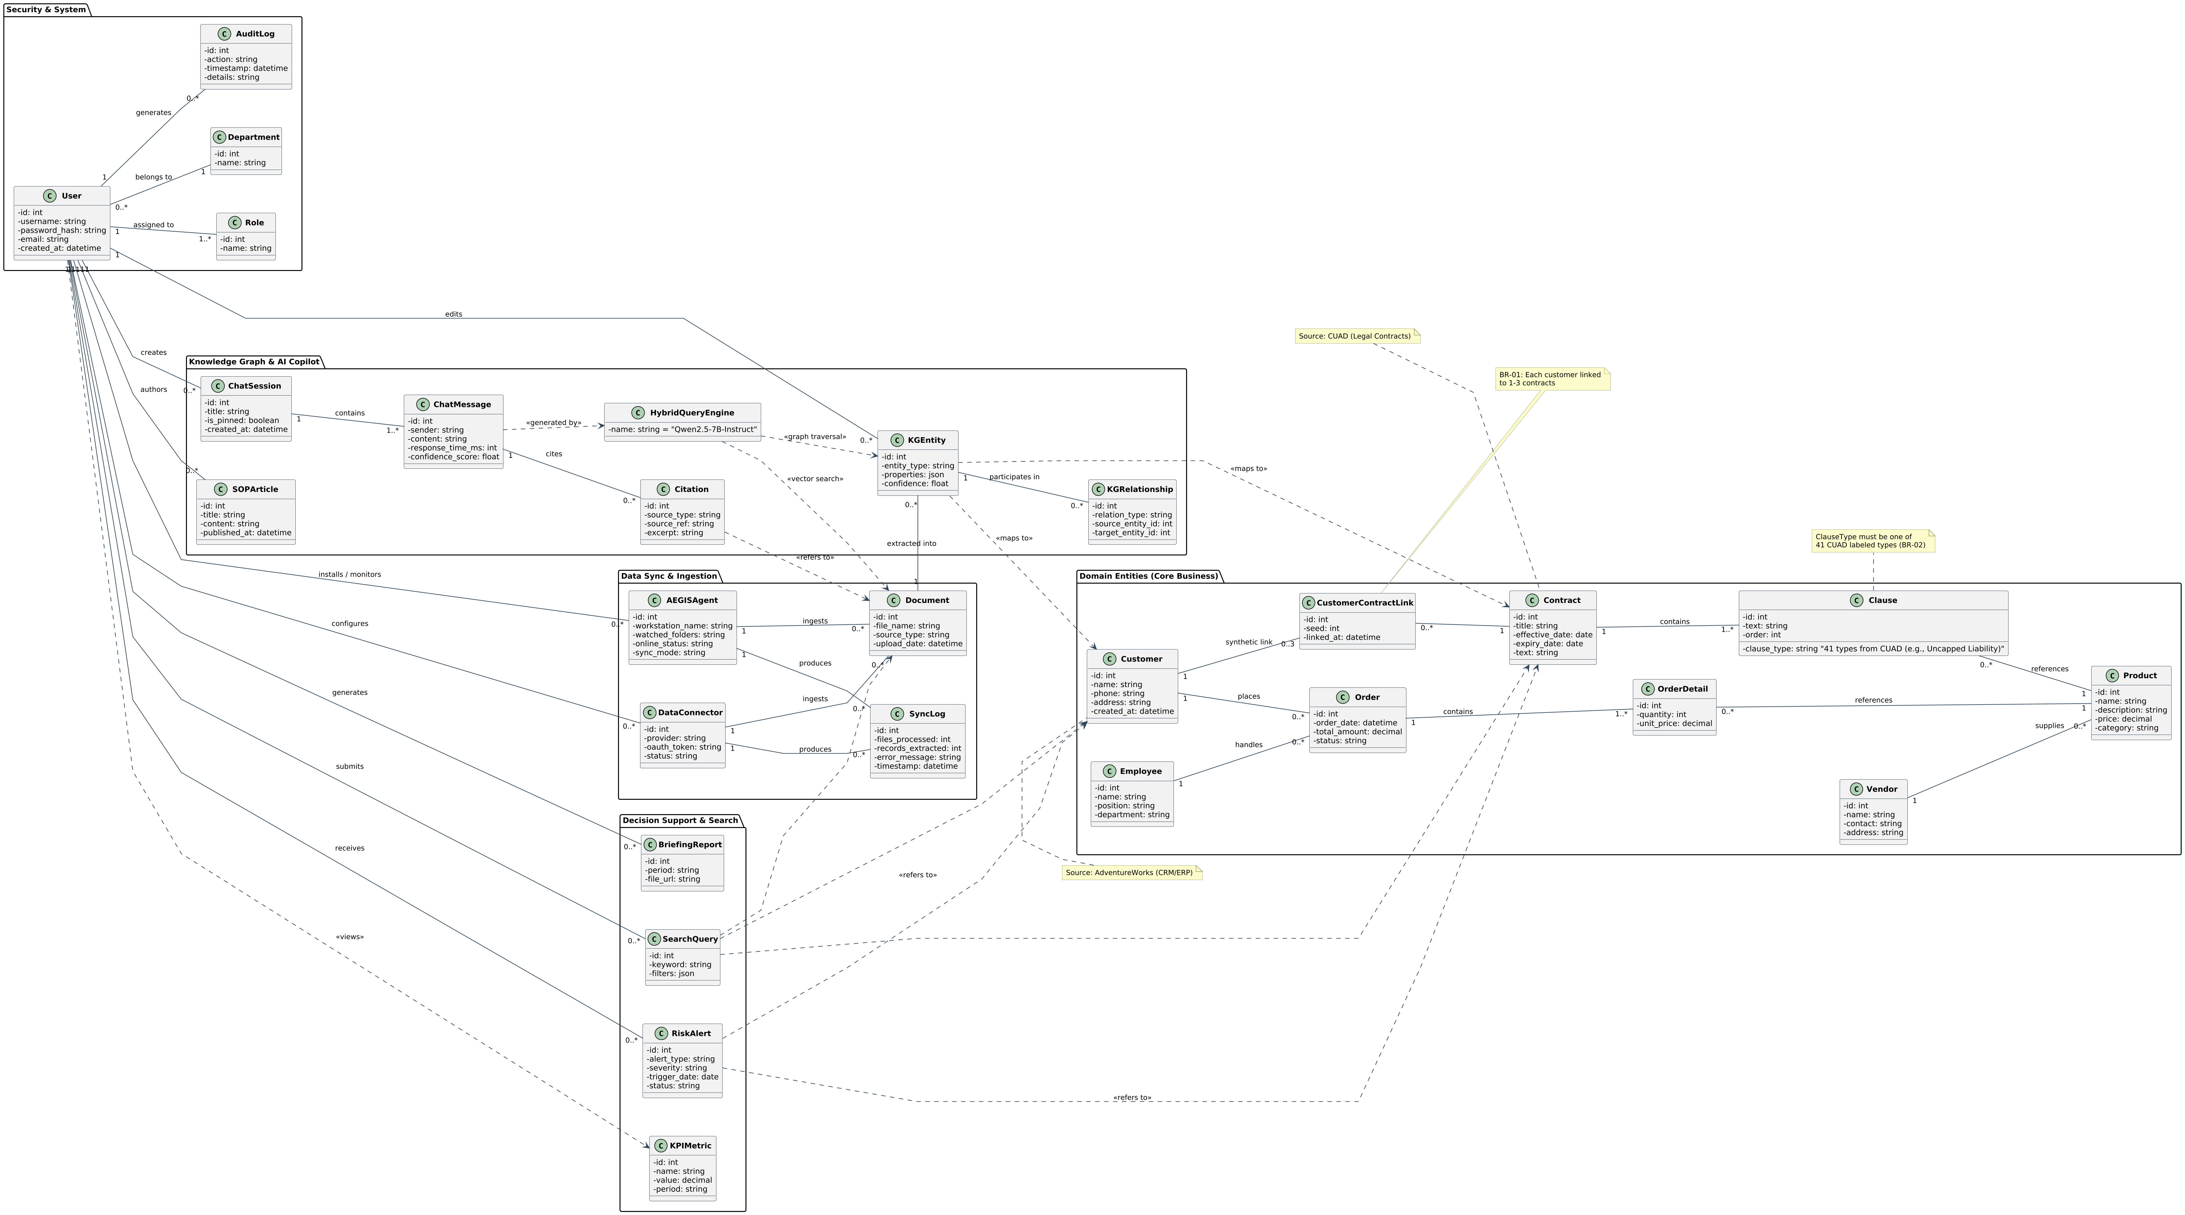
Figure 5.7 — GraphMind (EKAI) System Class Diagram

6. Other Requirements

6.1 Business Rules
ID | Business Rules
BR-01 | Each Customer in AdventureWorks is permanently assigned to 1–3 Contracts (CUAD) via an independent lookup table (Controlled Synthetic Linking).
BR-02 | Access to contract information and transaction data is strictly compliant with each user's RBAC, Department Scope, and Data Scope.
BR-03 | Only System & Knowledge Administrators are allowed to configure the AEGIS Agent and browse knowledge editing through the Knowledge Editor.
BR-04 | Department Managers are only allowed to draft and publish SOPs for their own departments.
BR-05 | Executives have unrestricted full-access to data across the enterprise.

6.2 System Constraints
- The system runs on a Web-based platform, supporting hybrid deployment.
- Integrates Neo4j (Graph DB), Qdrant (Vector DB), PostgreSQL (Relational DB), and FastAPI (Backend) simultaneously.
- The fine-tuned Qwen2.5-7B-Instruct model is self-hosted, not calling third-party LLM APIs.
- Frontend React/Next.js Backend communication via REST API pays JSON.
- Fine-tuning is limited to Kaggle's free T4 GPU quota (~30 hours/week).

Appendix

A: Glossary
Terminology | Explanation
GraphRAG | The RAG method retrieves context by browsing knowledge graphs instead of just searching for text.
Knowledge Graph | A graph of entity nodes (Customer, Product, Order, Employee, Vendor, Contract, Clause) and the relationships between them, stored on Neo4j.
Hybrid Query | Query simultaneously through two channels: Neo4j graph browsing and Qdrant vector search.
Context Fusion | The step of merging, deduplication, and ranking results from the two retrieval channels before inclusion in the LLM.
Text-to-Cypher | Convert natural language questions into Cypher statements to query Neo4j.
LoRA | The fine-tuning technique only trains the low-grade adapter matrix, keeping the original model weight.
PEFT | The group of methods of fine-tuning the parameter effectively, only training a small part of the parameter.
AEGIS Agent | File Watcher program installed at the enterprise, detects file changes and incremental synchronization to the Cloud.
Controlled Synthetic Linking | The process assigns each Customer with 1–3 CUAD contracts according to the rules and fixed seeds, stored in an independent table.
LLM-as-Judge | Use a language model to score answers against standard answers, corrected by manual testing.

Appendix B – Requirement Traceability Matrix
BR → FR trace table → API → Test Case. Test Case ID and Status columns are blank, which will update after writing document 9. System Testing-Report.docx.
BR ID | Business Requirement Description | FR ID | Functional Requirement Description | API Endpoint | Test Case ID | Status
BR-01 | CRM and contract data must be linked to answer cross-source questions. | FR18 | Assign each customer to 1–3 CUAD contracts via an independent lookup table. | /api/v1/linking/customer-contract
BR-01 | Associative knowledge must be included in a queryable graph. | FR21 | Build the Knowledge Graph on Neo4j according to the mapping schema. | /api/v1/knowledge/graph/build
BR-01 | The inter-source question must have evidence from both sources. | FR30 | Answer cross-source questions and cite both CRM data and terms. | /api/v1/copilot/query
BR-02 | Users must be securely authenticated before accessing data. | FR1 | Login authentication with JWT. | /api/v1/auth/login
BR-02 | Users must regain secure access. | FR2 | Registration, forgot password and OTP authentication. | /api/v1/auth/register
BR-02 | Data access must be according to the role and scope of the data. | FR3 | RBAC decentralization combines Department/Data Scope. | /api/v1/rbac/check
BR-02 | Citations must not expose data out of scope. | FR32 | Display source citations within the allowed range. | /api/v1/copilot/citations
BR-02 | Every action must be traceable. | FR6 | Record queries and administrative actions in the Audit Log. | /api/v1/admin/audit-logs
BR-02 | Sensitive data must be protected in transit. | FR7 | HTTPS/TLS encryption when syncing Agent – Cloud. | /api/v1/sync/push
BR-03 | Only Admins are configured to sync locally. | FR13 | Agent settings, change detection, and incremental synchronization. | /api/v1/sync/incremental
BR-03 | Admins must be able to monitor all agents. | FR14 | The AEGIS Local Agent Panel displays the status and configuration. | /api/v1/agents
BR-03 | Admins must be able to correct the wrongly extracted AI knowledge. | FR24 | The Knowledge Editor allows CRUD nodes and relationships. | /api/v1/knowledge/entities
BR-03 | Corrections must take effect with subsequent replies. | FR25 | Sync editing to Neo4j and Qdrant. | /api/v1/knowledge/sync-embeddings
BR-04 | Department Managers only publish SOPs for their departments. | FR26 | Draft and publish limited SOPs according to RBAC. | /api/v1/sop/publish
BR-05 | Executives must be able to view aggregate business metrics. | FR41 | Executive Decision Dashboard with pivot charts. | /api/v1/dashboard/executive
BR-05 | Executives must be warned of proactive risks. | FR42 | Smart Risk & Alert Center alerts contracts and clients. | /api/v1/alerts/risk
BR-05 | Executive Q&A strategy across the entire data. | FR27 | Multi-turn Copilot chat with full scope. | /api/v1/copilot/query

